 | 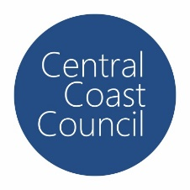
COUNCIL ASSESSMENT REPORT
HUNTER AND CENTRAL COAST REGIONAL PLANNING PANEL

PANEL REFERENCE & DA NUMBER | DA/919/2018 – PPSHCC-84
PROPOSAL | The proposed development comprises a Torrens title subdivision to be carried out in a number of stages (Stages 6a, 6b & 7) creating 92 residential lots between 314m² and 650m², one residential super lot, one commercial lot, and three residue lots
ADDRESS | Lot 1 DP 371647, Lot 1 DP 375712, Lot 1 DP 376264, Lot 41 DP 1200210, Lot 51 and 52 DP 561032 and Lot 54 and 55 DP 7527 - 99-107 Sparks Road and 236-260 Hakone Road Woongarrah NSW 2259
APPLICANT | Julie Garratley – Beveridge Williams
OWNER | Central Coast Council
DA LODGEMENT DATE | 10 June 2021 (Application for review of determination)
APPLICATION TYPE | Integrated Development Application
REGIONALLY SIGNIFICANT CRITERIA | Clause 3(b), Schedule 7 of the SRD SEPP: Land owned by Council and development with a CIV of more the $5M.
CIV | $11.2M as lodged (excluding GST)
CLAUSE 4.6 REQUESTS | N/A
KEY SEPP/LEP | - State Environmental Planning Policy (State and Regional Development) 2011  - State Environmental Planning Policy 55 – Remediation of Land  - State Environmental Planning Policy (Infrastructure) 2007  - State Environmental Planning Policy (Koala Habitat Protection) 2021  - Wyong Local Environmental Plan 2013  - Wyong Shire Development Control Plan 2013  - Chapter 1.2 – Notification of Development Proposals  - Part 4 – Subdivision  - Chapter 5.5 – Warnervale Town Centre
TOTAL & UNIQUE SUBMISSIONS KEY ISSUES IN SUBMISSIONS | No Public Submissions Received
DOCUMENTS SUBMITTED FOR CONSIDERATION | - Plan of Proposed Subdivision of Lot 1 DP371647, Lott 1 DP375712, Lot 41 DP 1200210, Lots 54 & 55 DP 7527, Lots 51 & 52 DP 561032 & Lot 1 DP 376264 – Sheet 1, Issue L dated 5/11/2021, Prepared by Beveridge Williams  - Concept Engineering Drawings, Sheets 1-24, Issue P0, dated 10/11/2021, Prepared by Beveridge Williams
SPECIAL INFRASTRUCTURE CONTRIBUTIONS (S7.24) | Yes – Warnervale Town Centre – Special Contributions Area
RECOMMENDATION | Approval
DRAFT CONDITIONS TO APPLICANT | No
SCHEDULED MEETING DATE | 22 November 2021
PLAN VERSION | Select Date Version No
PREPARED BY | Nathan Burr
DATE OF REPORT | 15 November 2021

EXECUTIVE SUMMARY

An application has been received under Section 8.2 of the Environmental Planning and Assessment Act, 1979 (the Act) for the Hunter and Central Coast Regional Planning Panel (RPP) to review its decision on the determination of DA919/2018 for a residential subdivision (Integrated Development) on land at 99-107, 111 Sparks Road and 236-260 Hakone Road, Woongarah NSW 2259.

The Application was refused by the RPP on 21 December 2020. The reasons for refusal are included below:

- The proposed development is identified as bushfire prone land and Integrated Development, a Bushfire Safety Authority (BSA) specific to the proposal as amended has not been issued by the Rural Fire Service as the application is not supported by;
- A bushfire report that demonstrated that the proposed subdivision meets the relevant requirements of Planning for Bush Fire Protection (PBP) 2019; and,
- Evidence that demonstrates that the proposed allotments can meet the minimum asset protection zones (APZs) in Table A1.12.2 of PBP 2019 for the life of the development; especially where APZs are proposed external to the proposed lots to the north and offsite to the east.

2. The proposal fails to demonstrate consistency with the provisions of Wyong Development Control Plan 2013 in accordance with the provisions of, the following matters have not been addressed and satisfied”.
i. Chapter 5.5 Clause 3.2 – the proposed street hierarchy and design is inconsistent with the adopted DCP requirements in figures 3.1, 3.2 and clause 3.3. The proposal does not satisfy the objectives for the Street Hierarchy and Design controls or the objectives for Landscaping In The Road Reserve Control.
ii. Chapter 5.5 Clause 7.1. The proposed subdivision does not represent best practice in landscape and urban design. There is insufficient consideration of issues relating to solar access including a dominance of east- west lots, servicing, access and street conflicts, location (extent and height) of retaining walls and sizing of corner lots for which the future dwellings have not been provided.

- A detailed servicing plan proposed stages 6 and 7 has not been provided. Any servicing plan is required to consider future demands of residue residential land (lot 601) and is required to satisfy cl6.2 and cl7.9 of Wyong Local Environmental Plan 2013.

4. Inadequate engineering detail to support variations to Wyong Development Control Plan 2013 Chapter 5.5, Section 3 Traffic and Movement, have been provided and include:
a. Inadequate information is available to determine if adequate “safe intersection sight distance” is provided at the intersection of ROAD MC01 & MC11 due to the crest in MC01.
b. Proposed Road MC01 is not designed in accordance with Austroads. The curve radius on MC01 is below acceptable design criteria based on the design speed & adverse crossfall. This tight horizontal curve maybe more critical due to the proximity of the adjoining over vertical curve (crest).
c. The proposal has not demonstrated that the design vehicle turning path of a garbage truck (12.5m garbage truck and emergency vehicles) can be accommodated within the proposed road construction.
d. The proposal fails to consider how the road network would tie into a layout for the residue lot to the south and address matters including the:
i. Location of 100yr major over land flow path and suitable location of the minor piped system. Duplicated systems are not supported.
ii. Sewer servicing needs to be demonstrated.
e. The proposed roads do not comply with Council’ standards for road construction and insufficient detail is provided to warrant variation of the minimum standards. More detailed consideration of verge widths are required to ensure widths that can satisfactorily accommodate street trees, street light columns (& footings), concrete footpath/s, water mains, gas mains, communications & underground power with the required & safe separations between these utilities.
f. The traffic and safety benefits of the proposed one way sections of road have not been demonstrated. In addition, the lack of pedestrian facilities in this portion of the development will force pedestrian onto the roadway.
g. The earthworks cut & fill information highlights quite steep grades over the site & no information provided to identify the location of retaining walls.
5. The proposed street and lot layout is considered unsatisfactory and unsuitable as the design is insensitive to the topography and other constraints and opportunities of the site.

The application has been examined having regard to the matters for consideration detailed in Section 4.15 and Section 8.2 of the Environmental Planning and Assessment Act 1979 (EP&A Act) and other statutory requirements with the issues requiring attention and consideration being addressed in the report.
The proposed development has been amended to address the reason for refusal and now comprises a Torrens title subdivision to be carried out in several stages (Stages 6a, 6b & 7) creating 92 residential lots between 314m² and 650m², one residential super lot, one commercial lot, and three residue lots.

There have been no public submissions received with respect to the application for review of the determination. The NSW Rural Fire Service has issued General Terms of Approval with respect to the development and Council internal assessment officers generally support the development subject to conditions of consent.

- THE SITE AND LOCALITY

  - The Site

The subject site is commonly known as 99-107 Sparks Road and 236-260 Hakone Road Woongarrah and is legally described as Lot 1 DP 371647, Lot 1 DP 375712, Lot 1 DP 376264, Lot 41 DP 1200210, Lot 51 and 52 DP 561032 and Lot 54 and 55 DP 7527.
The subject site is within the Warnervale Town Centre (WTC) and is located north of Sparks Road and continues north to Hakone Road. The subject site has an overall site area of approximately 23.84 ha however, the area of the site which is the subject of the proposal is a 5.8 ha portion generally between Sparks Road and the future alignment of Mataram Road. An aerial photo of the site showing the cadastral boundaries and a more recent aerial photo of WTC with the approximate area to be developed are included below.
Figure 1: Site extent

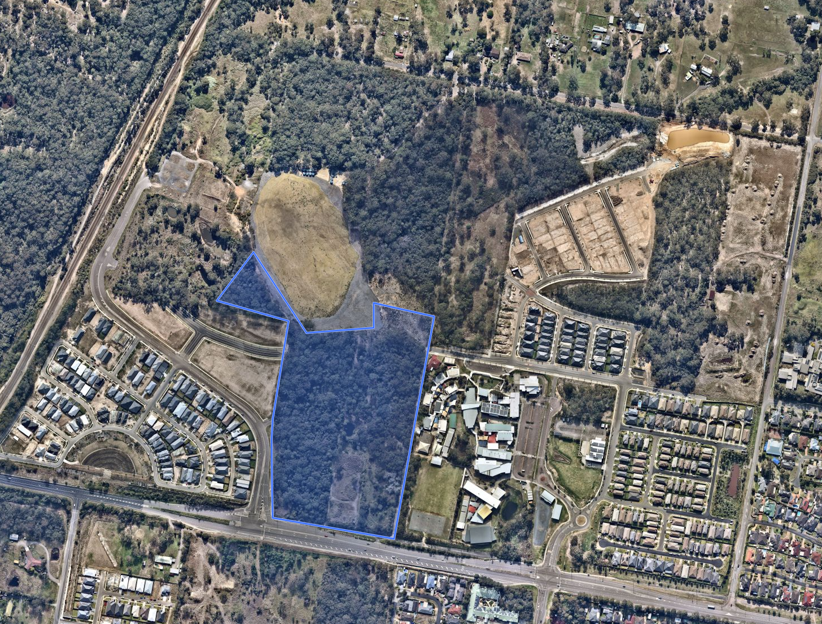
Figure 2: August 2021 aerial photo of WTC showing the approximate area to be developed
The site is characterised by a ridge that is generally oriented east west through the WTC area, the western extent of which forms the future Hilltop Park which is a 5.3 ha RE1 zoned portion of land to be retained by Council. The area to be developed is generally south of the Hilltop Park area and the site in this location generally slopes from north to south and west to east. The slope is moderate leading away from the ridge flattening out on approach to Sparks Road. An aerial photo with contour lines is included below.
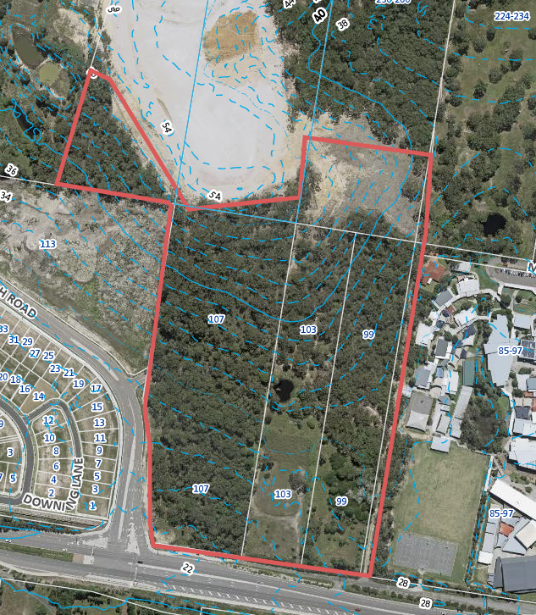
Figure 3: 2019 aerial Photo and 2m contours
The site is zoned R1 General Residential, RE1 Public Recreation, E2 Environmental Conservation and E3 Environmental Management under the Wyong Local Environmental Plan 2013 (WLEP 2013). The site is not identified by the WLEP 2013 as containing heritage items but is located within the Warnervale Town Centre Urban Release Area (URA). A zone map of WTC is included below.
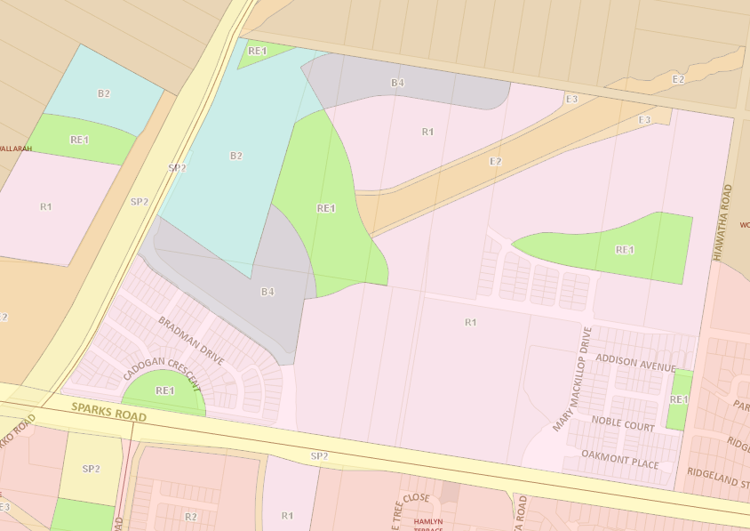
Figure 4: Warnervale Town Centre precinct
The WLEP 2013 does not stipulate a minimum lot size for the R1 zoned portion of the site however, the Environment zones have a minimum lot size of 40 ha while the RE1 zoned land is identified for acquisition for the purposes of local open space.
The site is identified as being bushfire prone land but is not subject to flooding or located within a mine subsidence district. The area of the site zoned RE1 has been identified as being contaminated land which is in the process of being remediated as part of a project being undertaken by the Council.
The site is currently vacant and highly disturbed however, does contain remnant vegetation comprising the Plant Community Type (PCT) Turpentine - Smooth-barked Apple - Broad-leaved Mahogany shrubby open forest on sandstone ranges of the Central Coast.

  - The Locality

The WTC commenced formal planning in early 2000, culminating in a rezoning of the site under the provisions of State Environmental Planning Policy (SEPP) Major Projects 2005 as Amendment No. 24 in November 2008. The rezoning was to enable the creation of a new town centre with supporting retail, mixed use, and residential development to provide approximately 1650 dwellings and create 1,200 jobs.

The Warnervale Town Centre Development Control Plan was formulated with the rezoning which has since been adopted by Council and is now known as Chapter 5.5 of the Wyong Development Control Plan 2013 (WDCP 2013).
A Special Infrastructure Contribution (SIC) Plan for the WTC came into effect in October 2008. The plan levied $140,000 (subject to indexation) per ha of Net Developable Area (NDA) to contribute to regional infrastructure upgrades (e.g., M1 Pacific Motorway Interchange with Sparks Road) and payments associated with Biodiversity Offsets required by the Biocertification process.

The site was Biodiversity certified on 30 January 2014 for a period of 25 years.
An indicative structure plan of WTC from Chapter 5.5 of WDCP 2013 is included below.
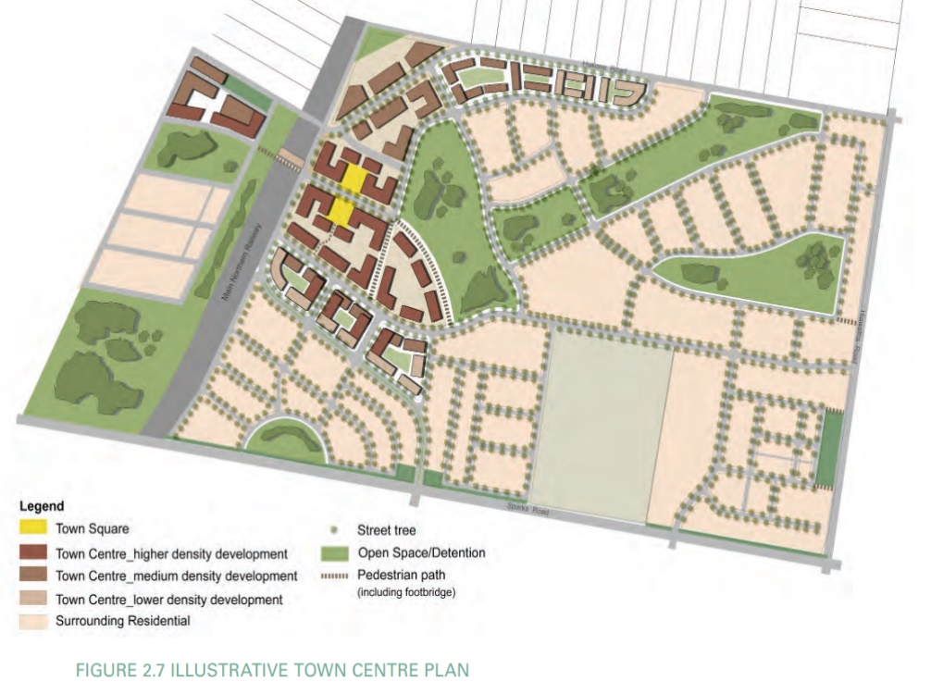
Figure 5: Warnervale Town Centre Structure Plan – WDCP 2013 – Chapter 5.5

Residential development has typically taken the form of detached dwellings including examples of zero side setback dwellings with lots typically ranging in area from 300-600m². Multi dwelling housing and residential flats are permitted within the zone and some areas of the R1 zone permitted a height of building of 12m however, this type of development has not been taken up to date with density being achieved by relatively smaller lots and single dwellings.
There are a number of residential subdivisions that have been approved within WTC which have either been commenced, completed or nearing completion as summarised in the following figure.

Figure 6: Warnervale Town Centre Development Applications and Consents
Significant features of the locality include Sparks Road on the southern boundary of the subject site and WTC in general which is a classified road connecting existing and emerging urban areas to the M1 Motorway located west of the site. The Main Northern Rail line bounds the western edge of WTC.
Located centrally to WTC and adjoining the eastern boundary of the site is a K-12 School which is adjacent to a GP Superclininc.

THE PROPOSAL AND BACKGROUND

  - The Proposal

The proposed development comprises a Torrens title subdivision to be carried out in several stages (Stages 6a, 6b & 7) creating 92 residential lots between 314m² and 650m², one residential super lot, one commercial lot, and three residue lots. The subdivision works include the following:
- Construction of new roads;
- Bulk earthworks, lot regrading and retaining;
- Construction of a bio retention and stormwater detention basin;
- Provision of underground water, sewer, communication (NBN) and electrical services as required including any external connections;
- Removal of vegetation across the development site;
- Creation of any necessary easements; and
- Landscaping including street trees along all roads and wetland tolerant plants within the biofiltration basin.
The proposed development is to be staged as follows:
Stage 6a – Sparks Road frontage portion of site
- One Super lot (proposed Lot 601) for future development including easements and a basin, 2.555 ha in area. The proposed lot has frontage to Sparks and Woongarrah Roads, with access to be obtained from the proposed subdivision roads.
Stage 6b – central portion of site
- 48 residential lots with access from new roads connecting to Woongarrah Road to the west. The proposed residential lots vary in size from 330m² to 453m².
Stage 7 – to the north of Stage 6b
- 44 residential lots with access from the extension of Mataram Rd in the north and the new roads connecting to Woongarrah Road to the west. The proposed lots vary in size from 314m² to 654m².
- One mixed use lot zoned B4 (1.116 ha) for future development.
The residue of the site comprises 9 ha of areas zoned of R1, B4, E2 and E3 zoned land that will be the subject of a future development application(s) and 5.3 ha which will form the future Hilltop Park.

Table 1: Development Data
Control | Proposal
Site area | 23.843 ha
Minimum Lot Size | No LEP standard
Clause 4.6 Requests | No
No. of Lots | 92 Residential lots (314m² and 650m²)  1 Super lot (2.555 ha)  1 B4 residue lot (1.116 ha)  3 residue lots
New Roads | Yes
Reticulated Services | Yes
Open Space | No
Cut/Fill | Bulk earthworks included retaining proposed. Max. retaining 3.0m
SIC/URA | Yes, Warnervale Town Centre – Special Contributions Area

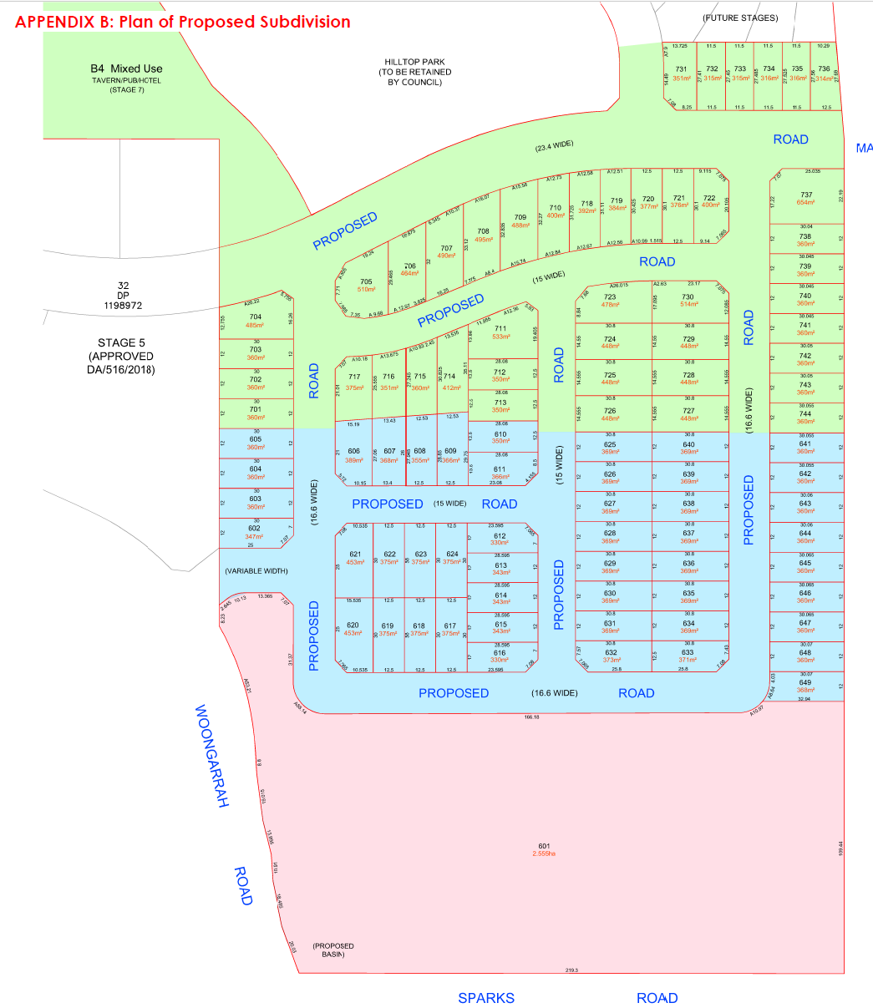
Figure 7: Proposed Subdivision

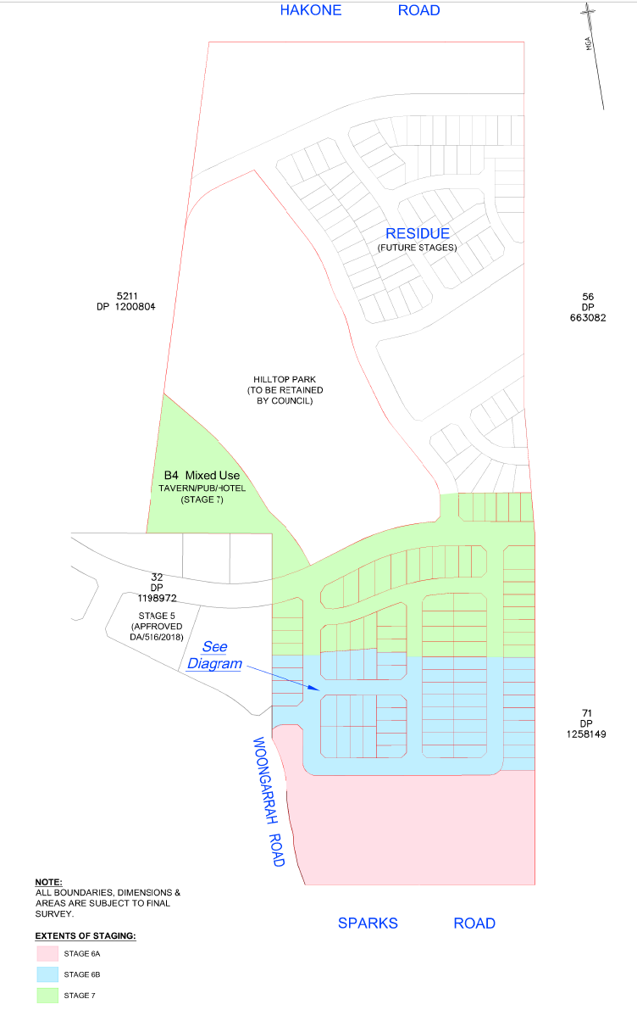
Figure 8: Proposed Staging Plan

  - Background

This s8.2(1)(a) review is the result of DA919/2018 being refused development consent by the Hunter and Central Coast Regional Planning Panel on 21 December 2020. The reasons for refusal and applicant’s response to these reasons are included in Table 2.

The key issues cited by the Panel in the Determination and Statement of Reasons are:

- Road widths and layout,
- Location of road intersection and safety and sight line distance (concerning the extension of Mataram Road which is identified as Road 01 in the current application),
- Implications of any changes to the height and extent of retaining walls along public recreational space,
- Interface with the adjoining school site and lands to the north,
- Urban design in respect to the number of east/west oriented lots and solar access and amenity outcomes for future dwellings,
- Identification of finished levels,
- Lack of RFS sign off, and
- Appropriateness of height of any proposed retaining walls.

The proposal that was refused by the Panel was originally submitted as a 160 lot residential subdivision and was subsequently amended by the applicant, which altered the proposed road and lot configuration and introduced the super lot adjacent to Sparks Road (lot 601).

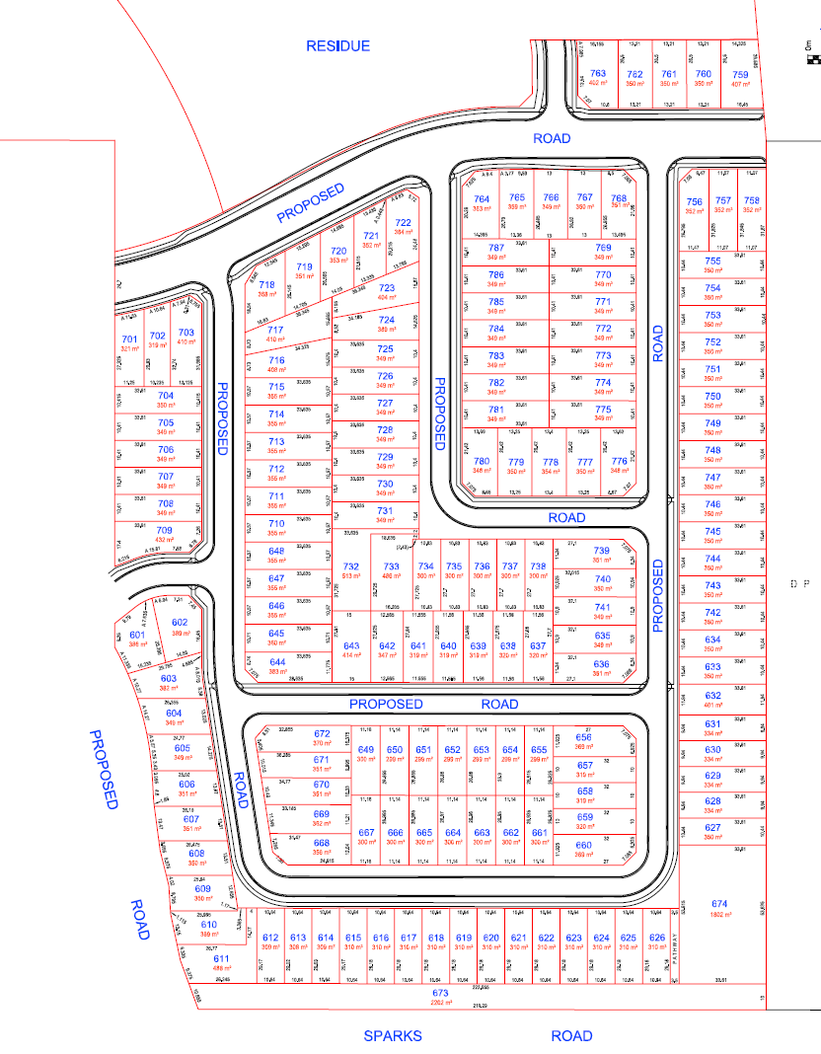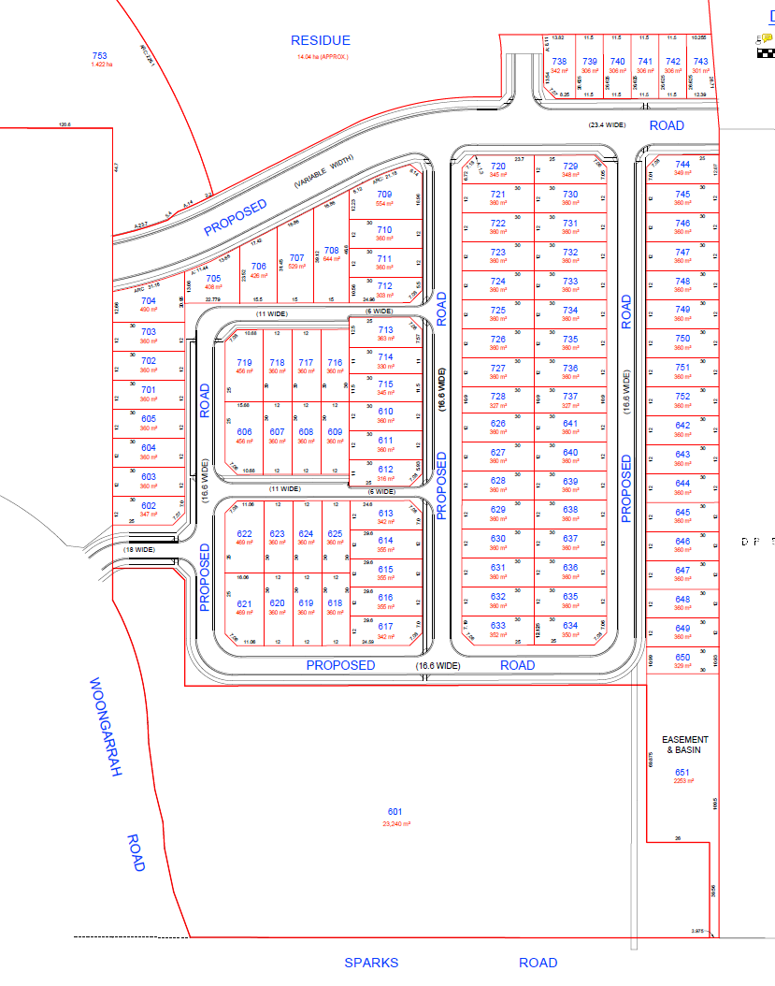
Figure 9: DA/919/2018 as lodged Figure 10: DA/919/2018 as determined
There were a number of matters which related to insufficient detail however, critically, the amended proposal had a number of significant road design and safety deficiencies which are highlighted in the figure below.

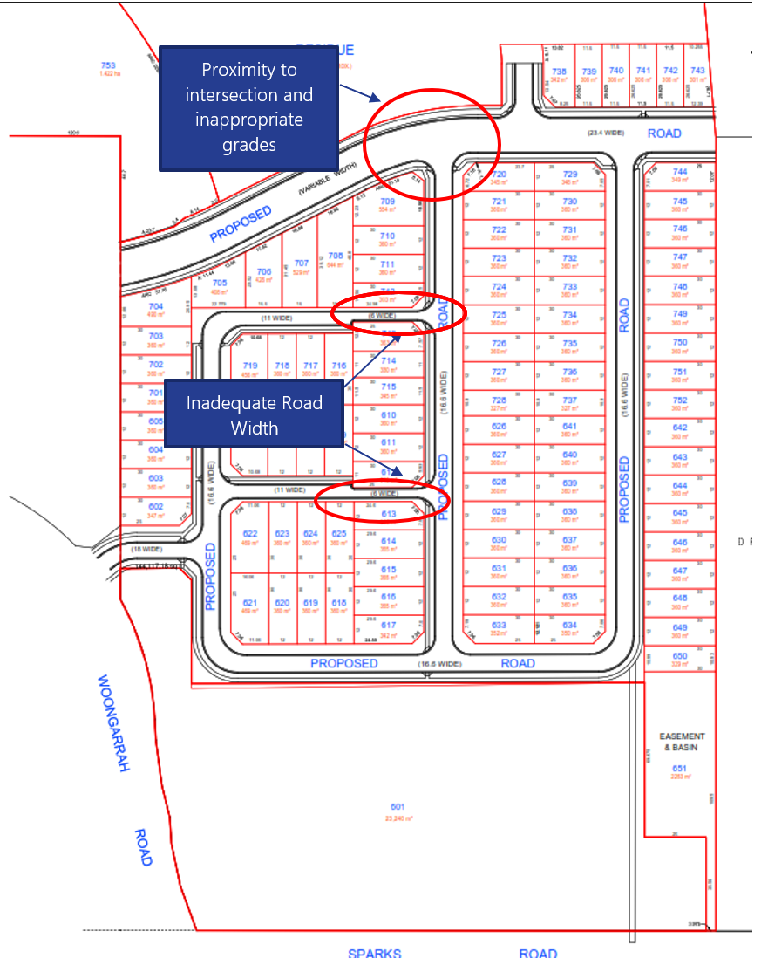
Figure 11: Road design flaws
The development application for review of determination was lodged on 10 June 2021. A chronology of the development application since lodgement is outlined below including the Panel’s involvement (e.g., briefings, notification etc.) with the application:

Table 2: Chronology of the DA
Date | Event
10 June 2021 | S8.2 Application lodged seeking a review of determination
11 June 2021 | Application referred to internal assessment officers and external agencies
25 June 2021 | Exhibition of the application
19 August 2021 | Panel briefing
2 November 2021 | Request for Information from Council to applicant
12 November 2021 | Amended plans lodged 12 November 2021 accepted by Council under Cl 55 of the Regulation on 12 November 2021. The amended plans include adjustment to road widths to accommodate parking within the street, adjustment to drainage scheme to relocate basin and additional details of the proposed retaining wall height and construction.
The applicant’s response to the reasons for refusal have been provided in the table below.

Reason for Refusal | Applicant’s Submission
- The proposed development is identified as bushfire prone land and Integrated Development, a Bushfire Safety Authority (BSA) specific to the proposal as amended has not been issued by the Rural Fire Service as the application is not supported by;  - A bushfire report that demonstrated that the proposed subdivision meets the relevant requirements of Planning for Bush Fire Protection (PBP) 2019; and,  - Evidence that demonstrates that the proposed allotments can meet the minimum asset protection zones (APZs) in Table A1.12.2 of PBP 2019 for the life of the development; especially where APZs are proposed external to the proposed lots to the north and offsite to the east. | A revised Bushfire Assessment Report is attached as Appendix B which shows the subdivision meets the planning requirements relating to Planning for Bush Fire Protection 2019.
Council Comment:

The NSW Rural Fire Service has issued a Bushfire Safety Authority with respect to the development.

2. The proposal fails to demonstrate consistency with the provisions of Wyong Development Control Plan 2013 in accordance with the provisions of, the following matters have not been addressed and satisfied”.  i. Chapter 5.5 Clause 3.2 – the proposed street hierarchy and design is inconsistent with the adopted DCP requirements in figures 3.1, 3.2 and clause 3.3. The proposal does not satisfy the objectives for the Street Hierarchy and Design controls or the objectives for Landscaping In The Road Reserve Control.  ii. Chapter 5.5 Clause 7.1. The proposed subdivision does not represent best practice in landscape and urban design. There is insufficient consideration of issues relating to solar access including a dominance of east- west lots, servicing, access and street conflicts, location (extent and height) of retaining walls and sizing of corner lots for which the future dwellings have not been provided. | To remove street conflict, the proposed middle intersection onto Mataram Road has now been removed.  The perimeter road extends around the subdivision from the eastern intersection on Mataram Road to the western intersection on Mataram Road and the western road access remains providing access to the subdivision via Woongarrah Road. The alignment of Mataram Road has been improved and traffic calming devices included to manage vehicle speed on Mataram Road and through the local roads within the subdivision.  The landscape plan for street tree plantings has been amended to reflect the current subdivision layout and is in accordance with the Figure 3.16 Street Tree Planting Strategy. The Landscape Plan is attached as Appendix C.  The strategy does not show planting in the local and neighbourhoods streets; however, some street tree planting has been proposed to create an attractive streetscape and contribute to the amenity of the subdivision.  The subdivision design is consistent with the guidelines found in Figure 7.1.  The subdivision has provided more north/south lots and a review of the finished levels show that all sites can achieve  adequate solar access for single dwellings which is a minimum of 3 hours to 50% of the principal private open space area which is 24m2 and provide adequate solar access for living areas within the dwellings.  The subdivision will include some benching and retaining walls to ensure that there are no inconsistencies between properties and interpretation by builders and property owners.  The lot sizes have been improved to ensure that suitable vehicle driveway locations are available. Previously smaller  corner lots have increased in area enabling dwellings to achieve adequate amenity or meet the requirements of dual street frontage residential development if desired.  The revised civil engineering plans are attached as Appendix E* and the revised subdivision plan attached as Appendix F* for reference.  The following tables provide a response to the objectives for the Street Hierarchy and Design controls and the objectives for Landscaping in the Road Reserve Control and the development controls of Clause 7.1 Neighbourhood and Subdivision Design.  * The engineering details were updated in an addendum to the application dated 11/11/2021.
Council Comment:

The proposed subdivision has adopted an approach to the street hierarchy which has been adopted in other subdivision developments within WTC wherein reduced road widths (carriageway and verge) have been utilised in conjunction with smaller lots to create a more compact neighbourhood. In this regard the proposal has a 16.6m ring road (road 03) and smaller 15m internal roads (roads 11, 12, 14).

Roads 12 and 14 were lodged at 11m in width and road 11 was 13.6m wide. The requirements of the Bushfire Safety Authority specify that a minimum carriage width of 5.5m must be provided and any parking provided must be beyond this minimum carriage width. To accommodate parking in the street, roads 12 and 14 were increased in width to 15m and road 11 was also increased to 15m wide to increase the width of the verge to accommodate additional landscaping.

The submitted landscaping design is adequate however, will require updating to reflect the wider roads. It is considered that landscaping details may be provided in accordance with a condition of consent.

The applicant has provided a revised turning path plan to demonstrate the required curve widening to accommodate a single unit heavy rigid vehicle (HRV) waste collection vehicle.

The internal road layout and circulation is generally consistent with the road and street hierarchy envisaged in WDCP Chapter 6.5 - Warnervale Town Centre Development Control Plan 2012 documents.

In this regard the refused scheme did not provide for a permeable and amenable street pattern that the current proposal now provides, which is a permeable street pattern with street lengths that reflect the structure plan.

The current proposal is supported by detailed earthworks plans and details of proposed retaining which has allowed for assessment of the solar access and amenity of the proposed lots. The proportion of N/S lots has been increased from 25% of the total proposed to 33%.

Clause 7.1 of WDCP Chapter 5.5 contains neighbourhood design principles for medium size lots such as those proposed in an E/W orientation. Due to the N/S slope of the land, the predominant orientation of the lots provides an effective mechanism to address the slope via a series of smaller successive steps which is evident on the earth works and retaining plans. The effect is observable in nearby Clover Lane depicted in the photo below.

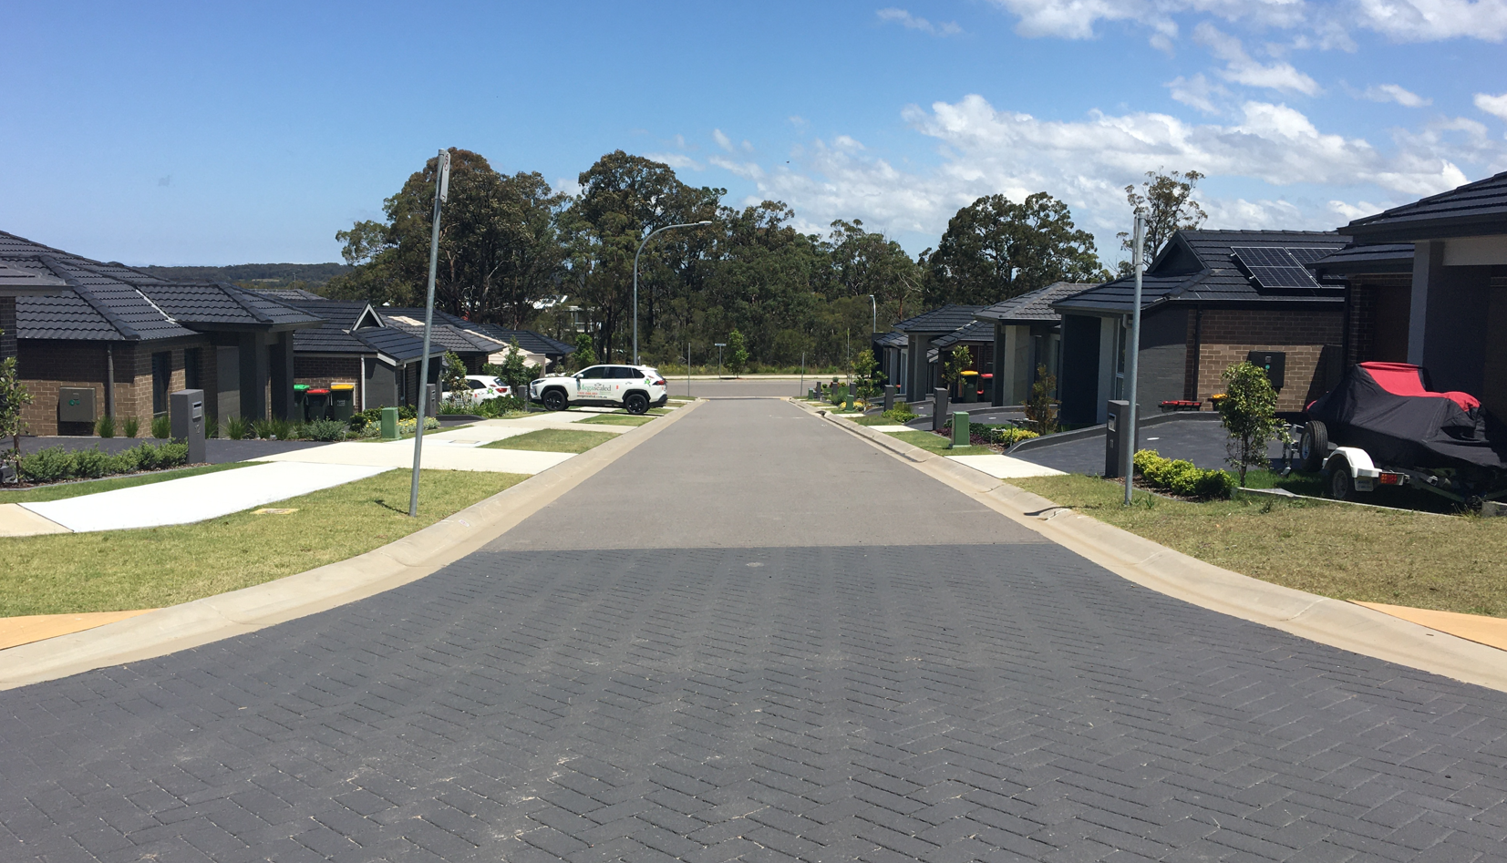
Figure 12: Clover Lane viewed from north to south

- A detailed servicing plan proposed stages 6 and 7 has not been provided. Any servicing plan is required to consider future demands of residue residential land (lot 601) and is required to satisfy cl6.2 and cl7.9 of Wyong Local Environmental Plan 2013. | Servicing plans which detail the water and sewer servicing strategy for the whole subdivision (Stages 6&7) is provided and attached as Appendix D*. The proposed servicing strategy can be augmented to provide services to the residue land (proposed Lot 601), when developed in the future.  *The stormwater drainage strategy was updated in the 11/11/2021 addendum.
Council Comment:

The 11/11/2021 addendum provided a revised stormwater management strategy which has been assessed and found to be consistent with WDCP Chapter 5.5 with regard to the location of the stormwater quality and detention basin, while providing satisfactory overland flow paths and connections to existing drainage infrastructure. The concept water and sewer details are considered satisfactory.

4. Inadequate engineering detail to support variations to Wyong Development Control Plan 2013 Chapter 5.5, Section 3 Traffic and Movement, have been provided and include:  a. Inadequate information is available to determine if adequate “safe intersection sight distance” is provided at the intersection of ROAD MC01 & MC11 due to the crest in MC01.  b. Proposed Road MC01 is not designed in accordance with Austroads. The curve radius on MC01 is below acceptable design criteria based on the design speed & adverse crossfall. This tight horizontal curve maybe more critical due to the proximity of the adjoining over vertical curve (crest).  c. The proposal has not demonstrated that the design vehicle turning path of a garbage truck (12.5m garbage truck and emergency vehicles) can be accommodated within the proposed road construction.  d. The proposal fails to consider how the road network would tie into a layout for the residue lot to the south and address matters including the:  i. Location of 100yr major over land flow path and suitable location of the minor piped system. Duplicated systems are not supported.  ii. Sewer servicing needs to be demonstrated.  e. The proposed roads do not comply with Council’ standards for road construction and insufficient detail is provided to warrant variation of the minimum standards. More detailed consideration of verge widths are required to ensure widths that can satisfactorily accommodate street trees, street light columns (& footings), concrete footpath/s, water mains, gas mains, communications & underground power with the required & safe separations between these utilities.  f. The traffic and safety benefits of the proposed one way sections of road have not been demonstrated. In addition, the lack of pedestrian facilities in this portion of the development will force pedestrian onto the roadway.  g. The earthworks cut & fill information highlights quite steep grades over the site & no information provided to identify the location of retaining walls. | - In consultation with Council, the road layout has been revised and is considered acceptable and adequate sight distance is now achieved.  - The road has been re-designed and is now in accordance with Austroads. The curve radius on MC01 has been rectified to the satisfaction of Council and is now based on acceptable design speed of 60km and has suitable crossfall. The curve has been relaxed to remove potential conflict at the crest. The amended design has been agreed upon with the Section Manager development Engineering.  - A plan showing truck movement for a 12.5m HRV has now been provided which shows that adequate manoeuvrability is fully available throughout the residential subdivision.  - The proposed road network in the residential subdivision can connect into the residue lot to the south by extending the north south roads. The major overland flow path and proposed stormwater pipe system is shown in the civil engineering package. The overland flow and stormwater system is designed to integrate with the residue lot and its future development. A gravity sewer main is proposed along the eastern boundary which extends from the north east and connects into the existing sewer main system on Sparks Road. The future development of the residue parcel will access the sewer main which will be constructed along the eastern boundary.  - * this part of the applicant’ submission has been superseded by the 11/11/2021 addendum. Which is included below.  Council’s comments regarding the width of the roads have been considered. The roads have been widened and are now 15m consisting of a 4.5m verge, 7.6m carriageway, 2.9m verge. The roads are shown on the amended plans as Road 12 and 14. The increased verge width provides for on street parking, adequate area for services and street trees. The increased width has removed the need for “No Stopping” signs on both sides of the street as one side can accommodate on-street parking. Adequate street landscaping can be provided, and the amenity of the occupants will not be impacted.  The width of north south road MC11 has also been widened to 15m which allows the street to be adequately landscaped resulting in a much improved and valued amenity. The widened road is shown on the amended plans as Road 11.  - The one-way sections have been removed.  - An earthworks plan is included with the revised plan set which shows the grades over the site. The site is at its steepest in vicinity of Mataram Road and reduces as it heads south. The design has considered the steeper parts of the site in the lot configuration and location of roads. The subdivision shows retaining wall locations and wall heights. The sites in the steeper part of the site are benched to provide a finished ground level and lots that are readily available to build upon. Benching of the steeper site removes irregular retaining and conflict between landowners.
Council Comment:

The applicant has provided a revised civil engineering package including a civil engineering report and drawings prepared by Beveridge Williams consulting, which was augmented by a further addendum dated 11/11/2021. The works will involve bulk earthworks and retaining walls, full road width construction including road, pavement, footpaths/shared paths, street and inter-allotment stormwater drainage, water quality basins and water and sewer servicing. Road reserve widths are generally in accordance with the requirements of WDCP 2013, Chapter 5.5 – Warnervale Town Centre and the RFS requirements. Works are to be in accordance with Council’s Civil works design guidelines.

The alignment and geometry of Mataram Road have been significanlty revised in comparison to the refused scheme and the design is considered to incorporate satisfactory safe intersection sight distances, pedestrain refuge and grades.

Eathworks are proposed across the site which includes benching of the lots and retaining walls. The retaining wall supporting Mataram Road is proposed to be up to 3.0m in height along the northern boundary of the lots. The location and geometry of Mataram Road is somewhat fixed by the existing portions of the road which the subject proposal will connect into. The proposed retaining wall adjacent to Mataram Road will contain a second wall comprising a planter box to reduce the visual impact of the wall from within the allotment. The applicant has submitted shadow diagrams that demonstrate that in spite of the relatively large height of retaining, the lots will be provided with adequate solar access. A typical section of the Mataram Road wall is included below.

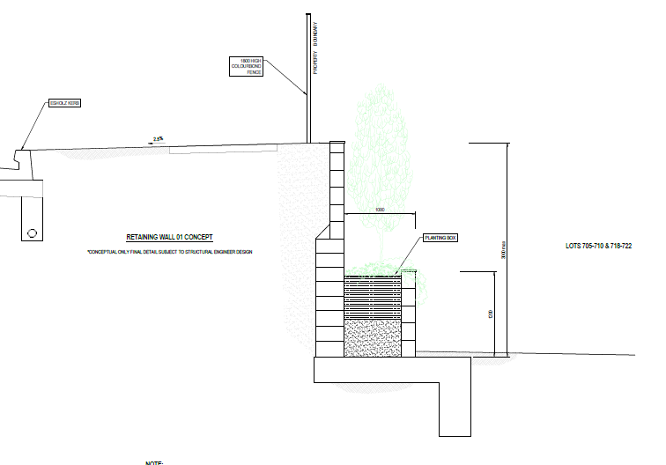

Figure 13: Mataram Road retaining wall typical detail
Other retaining walls that facillitate the benching of the lots have a maximum height of 1.6m but are generally not more than 1.2m in height.

- The proposed street and lot layout is considered unsatisfactory and unsuitable as the design is insensitive to the topography and other constraints and opportunities of the site. | The road design and lot layout has been amended (in extensive consultation with Council) to improve its suitability and sensitivity to the site topography.  As previously mentioned, the design has taken the natural topography into consideration and proposes an amended  Mataram Road alignment that is safe and suitable for the site and connects with adjoining development to the east  and west. The new Mataram Road transitions into the Mataram Road of Stage 5 with a more sensitive grade to the crest and curvature of the road.  The result is improved sight distance and improved road function. The number of intersections on Mataram Road have been reduced to remove intersection conflict.  In consultation with Council, the location of the future driveway to the tavern/pub/hotel has been taken into consideration with the amended road design to ensure that suitable driveway access can be achieved with the development of the B4 zoned lot in the future.  The topography of the land and street frontage was taken into consideration to determine that an adequate and safe driveway can be easily constructed as the entry to the future tavern premises.  The mix of lot sizes and orientations responds to the natural topography. The east/west lots where the slope rises to Mataram Road reduces the need for significant cut and fill and incrementally benches the individual lots where required.  This approach to the cut and fill of the site has enabled the future development of the lots to achieve adequate amenity in relation to solar access and privacy. The inclusion of retaining walls at the construction stage of the subdivision ensures the lots can be developed appropriately for residential occupation.
Council Comment:

The proposed development has been revised to address the engineering design deficiencies identified with the subdivision that was originally refused and the supporting design details demonstrate that the proposed road and lot configuration is acceptable in terms of WDCP Chapter 5.5 and is likely to provide opportunity for the erection of suitable dwellings in the future.

  - Site History

DA/188/2015 was approved for the remediation of the site which includes a program of gas monitoring to detect the presence of methane which may arise from decomposition within the former landfill area. Remediation works have been carried out to transform the area into a future public park, known as Hilltop Park, that will service the Warnervale Town Centre. The former landfill site and land requiring remediation is located within the subject site, these lands are not part of Stages 6a, 6b and 7 and are in the residue land.
The Council has lodged a Subdivision Certificate application (SC/80/2021) via the planning portal for the consolidation and subdivision of lots to create a lot retained by Council that will comprise the future Hilltop Park (Lot 2) with the balance being the land to be sold which includes the subject proposed residential subdivision (Lot 1).
The proposed development has been designed in accordance with the boundaries of the proposed allotment and it is noted that the remediation works and ongoing gas monitoring is contained to proposed Lot 2. A plan of the proposed SC/80/2021 subdivision is included below.
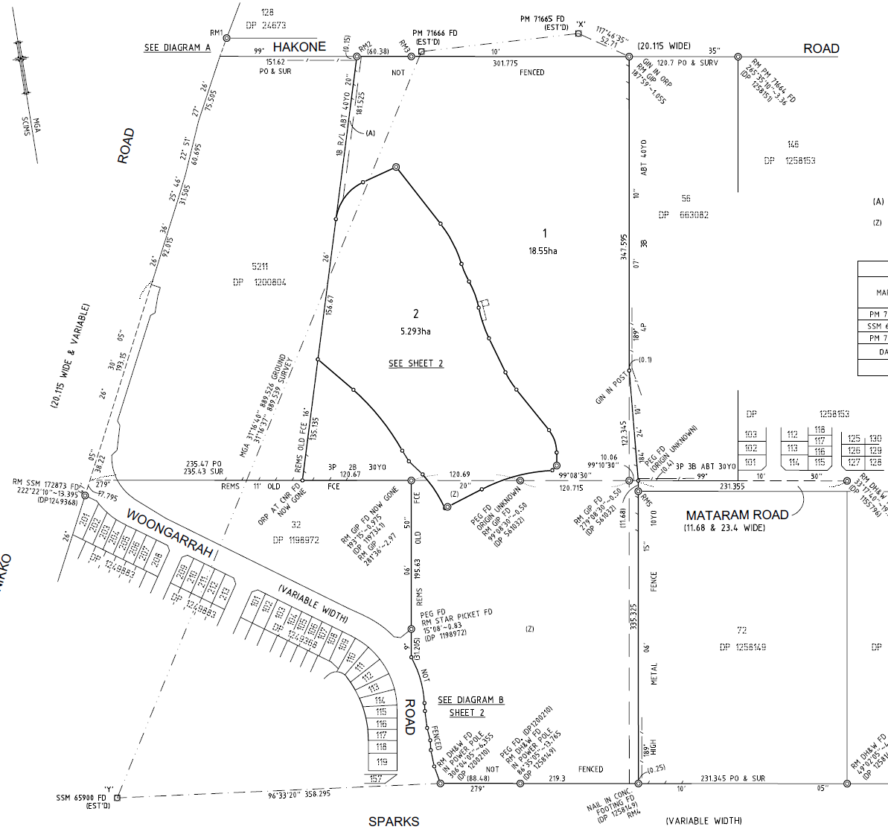
Figure 14: Proposed plan of subdivision under Subdivision Certificate 80/2021

- STATUTORY CONSIDERATIONS

When determining a development application, the consent authority must take into consideration the matters outlined in Section 4.15(1) of the Environmental Planning and Assessment Act 1979 (‘EP&A Act’). The matters as are of relevance to the development application include the following:

- the provisions of any environmental planning instrument, proposed instrument, development control plan, planning agreement and the regulations
- the likely impacts of that development, including environmental impacts on both the natural and built environments, and social and economic impacts in the locality,
- the suitability of the site for the development,
- any submissions made in accordance with this Act or the regulations,
- the public interest.

These matters are further considered below.

It is noted that the proposal is considered satisfactory having regard for the matters for consideration under s.4.15 as discussed further in this report.

- Integrated Development (s.4.46)

  - Section 4.15(1)(a)(i) - Provisions of Environmental Planning Instruments

The following Environmental Planning Instruments are relevant to this application:
- State Environmental Planning Policy (State and Regional Development) 2011
- State Environmental Planning Policy 55 – Remediation of Land
- State Environmental Planning Policy (Infrastructure) 2007
- State Environmental Planning Policy (Koala Habitat Protection) 2020
- Wyong Local Environmental Plan 2013

A summary of the key matters for consideration arising from the relevant State Environmental Planning Policies are outlined in Table 3 and considered in more detail below.

Table 3: Summary of Applicable State Environmental Planning Policies (Preconditions in bold)
EPI | Matters for Consideration | Comply (Y/N)
SRDD SEPP | - Clause 20(1) declares the proposal as regionally significant development pursuant to Clause 3(b) of Schedule 7.
SEPP 55 | - Clause 7 - Contamination and remediation has been considered in the Contamination Report and the proposal is satisfactory subject to conditions. | Y
Infrastructure SEPP | - Clause 101 Development with frontage to classified road  - Clause 102(2) Impact of road noise or vibration on non-road development  - Clause 104(3) - Traffic-generating development | Y
SEPP (Koala Habitat Protection) 2020 | - Clause 8(1) Step 1 - Is the land potential core Koala habitat? | Y
Wyong LEP 2013 | - Clauses 2.3, 4.1, 5.10, 6.1, 6.2 & 7.9 | Y

State Environmental Planning Policy (State and Regional Development) 2011

State Environmental Planning Policy (State and Regional Development) 2011 (‘SRD SEPP’) applies to the proposal as it identifies if development is regionally significant development. In this case, pursuant to Clause 20(1) of SRD SEPP, the proposal is a regionally significant development as it satisfies the criteria in Clause 3(b) of Schedule 7 of the SRD SEPP, being development of land owned by the Council with a CIV over $5 million.

Accordingly, the Hunter and Central Coast Regional Planning Panel is the consent authority for the application. The proposal is consistent with this Policy.

State Environmental Planning Policy No. 55 – Remediation of Land
Under the provisions of State Environmental Planning Policy (SEPP) 55 – Remediation of Land, contamination and remediation are to be considered in determining a development application. Clause 7(1) of State Environmental Planning Policy 55 requires that Council must not consent to the carrying out of any development on land unless it has considered whether the land is contaminated, and if contaminated, that the land is suitable in its contaminated state (or will be suitable, after remediation) for the development proposed to be carried out.
The site is identified as containing part of the former landfill area located within the RE1 zoned land and is not the subject of any proposed works under the terms of this development application.
The site is identified in Wyong DCP Chapter 5.5 – Warnervale Town Centre as being potentially contaminated given its former use as a landfill site. A preliminary site investigation for contamination was submitted in October 2020. This report has been reviewed by Council’s Environmental Health Officer and considered satisfactory.
Suitable conditions are recommended which require the submission of, and compliance with, any requirements of a Site Audit Statement, in addition to the implementation of an unexpected finds management plan to appropriately address any instances of asbestos containing material being discovered during works.

State Environmental Planning Policy (Infrastructure) 2007

Clause 101 -Development with frontage to classified road
The subject site has frontage to a classified road (Sparks Road) which engages clause 101. The consent authority must not grant consent to the development unless it is satisfied that:
(a) where practicable, vehicular access to the land is provided by a road other than the classified road, and
The development does not include access to the classified road.
b) the safety, efficiency and on-going operation of the classified road will not be adversely affected by the development as a result of:
(i) the design of the vehicular access to the land, or
(ii) the emission of smoke or dust from the development, or
(iii) the nature, volume or frequency of vehicles using the classified road to gain access to the land, and
The safety and efficiency of Sparks Road will not be impacted by the development. In this regard the signalised intersection of Woongarrah Road and Sparks Road was appropriately designed and constructed to accommodate the volume and nature of traffic generated by development within the Town Centre including the proposed subdivision. There are no upgrades to the classified road or any intersections or the like warranted in association with the proposal.
(c) the development is of a type that is not sensitive to traffic noise or vehicle emissions, or is appropriately located and designed, or includes measures, to ameliorate potential traffic noise or vehicle emissions within the site of the development arising from the adjacent classified road.
This matter is considered in more detail below in respect to clause 102, notwithstanding, subject to conditions of consent, the proposed development is not considered to be sensitive to traffic noise or vehicle emissions and will incorporate satisfactory amelioration measures to reduce potential impacts arising from vehicle noise or emissions associated with the classified road.
Clause 102 – Impact of road noise or vibration on non-road development
The proposed subdivision is for residential purposes and therefore the provisions of clause 102 of the Infrastructure SEPP should be considered. Ordinarily for development of residential accommodation the consent authority must not grant consent to the development unless it is satisfied that appropriate measures will be taken to ensure that the following LAeq levels are not exceeded:
(a) in any bedroom in the residential accommodation—35 dB(A) at any time between 10.00 pm and 7.00 am,
(b) anywhere else in the residential accommodation (other than a garage, kitchen, bathroom or hallway)—40 dB(A) at any time.
It is anticipated that the level of noise generated by the local roads would be sufficiently attenuated by the construction material used for the dwellings, the distance from the railway line and Sparks Road. Historical acoustic reports for the surrounding subdivision indicate that due to its location, additional studies will not be required.
Although not restrictive to the progression of this proposal, a conditional requirement should be imposed demonstrating that future residents will not be unreasonably impacted upon by the surrounding land uses. A condition of consent is recommended regarding the imposition of a s88b instrument requiring future residential development to comply with the above criteria.
Clause 104 – Traffic-generating development

The proposed subdivision is not a traffic generating development as per Schedule 3 of SEPP Infrastructure (i.e., Subdivision 50 or more allotments with access that connects to a classified road). Notwithstanding, consultation was carried out with the Roads Authority (Transport for NSW (TfNSW)) who raised no objections to the proposal subject to recommended conditions of consent. The matters raised by TfNSW and the recommended conditions of consent have been included in this assessment and recommended conditions of consent.

State Environmental Planning Policy No 44 - Koala Habitat Protection (SEPP 44)
State Environmental Planning Policy (Koala Habitat Protection) 2020
State Environmental Planning Policy (Koala Habitat Protection) 2021

The former SEPP 44 applied to the development when it was originally lodged. The ecological assessment submitted with the development application included a consideration of whether the site contains koala feed trees and/or forms of core koala habitat. The development application is supported by an ecological assessment prepared by a qualified ecologist, which included a specific consideration of the provisions of the former SEPP 44. In this instance, the site is not considered to be core koala habitat and a plan of management is not warranted prior to the granting of consent to the development.
State Environmental Planning Policy No 44 - Koala Habitat Protection has been repealed by State Environmental Planning Policy (Koala Habitat Protection) 2019 which has been repealed by State Environmental Planning Policy (Koala Habitat Protection) 2020. State Environmental Planning Policy (Koala Habitat Protection) 2021 has now been introduced and is operating concurrently with State Environmental Planning Policy (Koala Habitat Protection) 2020 having regard for Savings Provisions. As made, SEPP Koala Habitat Protection 2021 includes savings provisions under clause 18 which makes it as if the instrument had not commenced.
While the ecological assessment and report provided with the development application addresses the former SEPP 44 it is considered that the work submitted by the consulting ecologist satisfactorily addresses the provisions of State Environmental Planning Policy (Koala Habitat Protection) 2020.
Wyong Local Environmental Plan 2013 (WLEP 2013)
The Site is zoned R1 General Residential, B2 Local Centre, B4 Mixed Use, RE1 Public Recreation, E2 Environmental Conservation and E3 Environmental Management. Proposed Stages 6a, 6b and 7 predominantly involves the R1 General Residential land and one B4 Mixed Use allotment.
The RE1 land will remain within the northern residue allotment until the lot is excised from the site (being managed by the Council via SC/80/2021). The portions of the site zoned E2 and E3 will be contained within a residue lot.
Figure 15 : Zoning extract WLEP 2013 Stages 6 & 7 identified in red outline
Clause 2.3 – Permissibility and Zone Objectives
Subclause 2.3(2) of the WLEP 2013 requires the consent authority to have regard for the objectives for development in a zone when determining a development application.
The objectives of the R1 General Residential zone are:
- To provide for the housing needs of the community.
- To provide for a variety of housing types and densities.
- To enable other land uses that provide facilities or services to meet the day to day needs of residents.
- To promote “walkable” neighbourhoods.
- To ensure that development is compatible with the scale and character of the local area and complements the existing streetscape.
The objectives of the B4 Mixed Use zone are:
- To provide a mixture of compatible land uses.
- To integrate suitable business, office, residential, retail and other development in accessible locations to maximise public transport patronage and encourage walking and cycling.
- To permit residential accommodation while maintaining active retail, business and other non residential uses at street level.
- To encourage development that supports or complements the primary office and retail functions of the zone.
- To minimise conflict between land uses within the zone and land uses within adjoining zones.
The objectives of the R1 and B4 zones will be achieved as the proposed subdivision will provide residential allotments that will provide housing needs in accordance with the strategic vision for the area. The B4 zoned land will provide for a range of permissible uses that are in harmony with the B4 mixed use zone. The establishment of use on the B4 zoned land will be subject to a separate development application.
The Objectives of the RE1 zone are:
- To enable land to be used for public open space or recreational purposes.
- To provide a range of recreational settings and activities and compatible land uses.
- To protect and enhance the natural environment for recreational purposes.
- To provide linked open space for ecosystem continuity, public access, local community recreation and waterway protection.
- To provide space for integrated stormwater treatment devices for flow and water quality management.
- To enable ancillary development that complements land zoned for recreational purposes.
The proposal includes the construction of roads with the RE1 portion of the site as depicted in the figure below. The construction of roads within the RE1 zone is permissible with consent and in this instance the road alignment is fixed by the existing portion s of Mataram Road previously constructed east and west of the site. The minor incursion of road works into the RE1 portion of the site is essential for the completion of the road network envisaged by the DCP and will not undermine the future provision of public open space in accordance with the objectives of the zone.
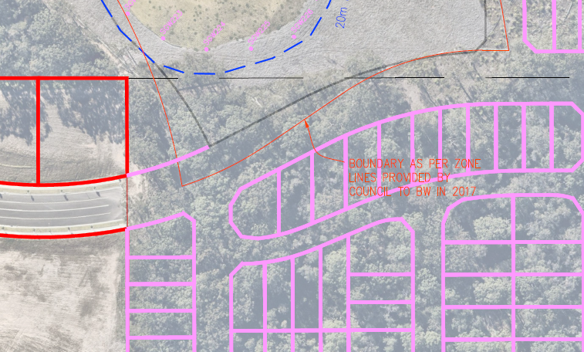
Figure 16: Road alignment of Mataram Road in relation to the RE1 zone boundary which is depicted in red (thin line).
The objectives of the E2 zones are:
- To protect, manage and restore areas of high ecological, scientific, cultural or aesthetic values.
- To prevent development that could destroy, damage or otherwise have an adverse effect on those values.
- To protect endangered ecological communities, coastal wetlands and littoral rainforests.
- To enable development of public works and environmental facilities if such development would not have a detrimental impact on ecological, scientific, cultural or aesthetic values.
The objectives of the E3 zones are:
- To protect, manage and restore areas with special ecological, scientific, cultural or aesthetic values.
- To provide for a limited range of development that does not have an adverse effect on those values.
The section of the site the subject of this application relates to the residential subdivision of the R1 General Residential zone under WLEP 2013. Under Clause 2.6 of WLEP 2013 land may be subdivided with consent. The remaining element of the subject site zoned E2 Environmental Conservation and E3 Environmental Management is not being subdivided and will be contained within a residual lot.
The following definitions are relevant to the proposal:
Subdivision of land means the division of land into two or more parts that, after the division, would be obviously adapted for separate occupation, use or disposition.
Road means a public road or a private road within the meaning of the Roads Act 1993 and includes a classified road.
Earthworks means excavation or filling.
The development satisfies the above definitions, as the development comprises Torrens Title subdivision, which is permissible with consent in the R1 General Residential zone. Additionally, development for the purposes of roads and earthworks is permissible within the R1 General Residential zone.
Clause 4.1 – Lot size
The LEP map does not provide a minimum lor size for the R1 zoned land.
Clause 5.10 – Heritage Conservation
Clause 5.10 requires the consent authority to consider the conservation of items of Aboriginal and European heritage.
An assessment was undertaken with a search of the NSW Office of Environment and Heritage (AHIMS) services (AHIMS – Aboriginal Heritage Information Management System) and no Aboriginal sites were recorded in or nearby the subject site or have been declared in or nearby the subject site.
A due diligence assessment under Section 8 of the Due Diligence Code of Practice for the Protection of Aboriginal Objects in New South Wales concluded that an AHIP application is not necessary, and works can proceed with caution, as the site is deemed to be disturbed land as it has been the subject of human activity that has significantly changed the subject land’s surface. Nevertheless, appropriate conditions have been provided as part of the consent to ensure that should any Aboriginal artefacts be found on site during construction that they are protected.
Clause 6.1 – Arrangements for Designated State Public Infrastructure
Clause 6.1 of WLEP 2013 requires that development consent must not be granted for the subdivision of land in an urban release area unless the Secretary has certified in writing to the consent authority that satisfactory arrangements have been made to contribute to the provision of designated State public infrastructure in relation to that land.
The site is shown on the urban release map. However, subclause (5) states that the clause does not apply to land in an urban release area if all or any part of the land is in a special contributions area as per Schedule 4 of the Act. The Warnervale Town Centre is identified in Schedule 4 as a special contributions area and clause 6.1 does not apply to the land.
Clause 6.2 Public utility infrastructure
Clause 6.2 requires that development consent must not be granted unless it is satisfied that adequate arrangements have been made for essential public utility infrastructure. The proposed development will require extension of all services, including water supply, electricity, telecommunications, and sewerage in accordance with the servicing strategies adopted for that purpose.
Arrangements can be made for the servicing of the new lots for electricity, the provision of vehicular access and satisfactory stormwater management subject to conditions. Each allotment will also have newly constructed road frontage allowing for formalised vehicular access and stormwater drainage.
The revised servicing arrangements submitted as part of the s8.2 application are considered to demonstrate that adequate arrangements have been made for the required essential public utility infrastructure.
Water and sewer contributions would be applicable to the development in accordance with the Shire Wide charges.
Clause 7.9 – Essential Services
In accordance with Clause 7.9, Council is required to ensure that services for water, sewer, electricity, stormwater drainage and road access can be adequately provided. The site has access to required essential services.

The proposal is considered to be generally consistent with the WLEP 2013.

  - Section 4.15 (1)(a)(ii) - Provisions of any Proposed Instruments

There are several proposed instruments which have been the subject of public consultation under the EP&A Act, and which may be relevant to the proposal, including the following:

- Draft Central Coast Local Environmental Plan 2018
- Draft Design and Place State Environmental Planning Policy (Design and Place SEPP)
- Draft State Environmental Planning Policy Environment (SEPP Environment)
- Review of Clause 4.6 of the Standard Instrument LEP

These proposed instruments are considered below:

Draft Central Coast Local Environmental Plan 2018
The proposal has been considered against the provisions of the Draft Central Coast Local Environmental Plan 2018 (DCCLEP). The land within Stages 6 and 7 remains predominately zoned R1 General Residential under Draft CCLEP.
Many of the existing zones in both former Local Government Areas will readily translate into equivalent zones in the Central Coast LEP (CCLEP). The draft CCLEP is generally the same as WLEP 2013 in respect to the issue of the land use permissibility/prohibition of the current application with a few small changes.
There are no additional or amended clauses or provisions warranting further discussion.

- Draft Central Coast Local Environmental Plan 2018
Draft Central Coast Local Environmental Plan 2018 (Draft CCLEP) was adopted by Council on 14 December 2020 and will replace the planning instruments relating to the former Local Government Areas. Under the provisions of Draft CCLEP, the site retains its zoning.
- Draft Design and Place State Environmental Planning Policy (Design and Place SEPP)
The Department of Planning, Industry and Environment (the Department) is preparing a new SEPP to replace and consolidate two existing SEPPs:
- SEPP No 65 – Design Quality of Residential Apartment Development; and
- SEPP (Building Sustainability Index: BASIX) 2004.

The Design and Place SEPP will establish principles for the design and assessment of places in urban and regional NSW.
The Explanation of Intended Effect of the draft Design and Place SEPP was on public exhibition until 31 March 2021. Following this public exhibition, the proposed Design and Place SEPP will be drafted and exhibited in late 2021 for further comment. The draft Design and Place SEPP will include specific considerations and targets that are more broadly proposed than the current Explanation of Intended Effect.
The Explanation of Intended Effect states that the proposed Design and Place SEPP is framed around five guiding principles. These principles aim to deliver healthy and prosperous places
that support the wellbeing of people, communities, and Country, being:
- Design places with beauty and character that people feel proud to belong to
- Design inviting public spaces to support engaged communities
- Design productive and connected places to enable thriving communities
- Design sustainable and green places for the wellbeing of people and the environment
- Design resilient and diverse places for enduring communities

The Draft Design and Place SEPP is intended to address subdivision of land and due to the number of lots proposed would be subject to precinct design and place considerations. The proposed development through consideration of Chapter 5.5 of the DCP has generally addressed the heads of consideration outlined in the draft instrument.
- Draft State Environmental Planning Policy Environment (SEPP Environment)

The Department intends to prepare a new SEPP for the protection and management of our natural environment. These areas are important to communities in delivering opportunities for physical health, economic security, and cultural identity.
This consolidated SEPP proposes to simplify the planning rules for several water catchments, waterways, urban bushland, and will consolidate the following:
- State Environmental Planning Policy No. 19 – Bushland in Urban Areas
- State Environmental Planning Policy (Sydney Drinking Water Catchment) 2011
- State Environmental Planning Policy No. 50 – Canal Estate Development
- Greater Metropolitan Regional Environmental Plan No. 2 – Georges River Catchment
- Sydney Regional Environmental Plan No. 20 – Hawkesbury-Nepean River (No.2-1997)
- Sydney Regional Environmental Plan (Sydney Harbour Catchment) 2005
- Willandra Lakes Regional Environmental Plan No. 1 – World Heritage Property.

The Explanation of Intended Effect for the Environment SEPP was on exhibition from 31 October 2017 until the 31 January 2018 and submissions are being considered.
As the proposed development site falls outside of the mapped areas for SREP 20 (Hawkesbury Nepean River), the draft SEPP has no application to the development proposed.
- Review of Clause 4.6 of the Standard Instrument LEP
A review of Clause 4.6 of the Standard Instrument LEP is currently being undertaken by the Department with the Explanation of Intended Effect placed on public exhibition from 31 March until 12 May 2021. The proposed development does not include any departure from development standards and is unlikely to be affected by any proposed changes to clause 4.6 of the Standard Instrument.
  - Section 4.15(1)(a)(iii) - Provisions of any Development Control Plan

The following Development Control Plan is relevant to this application:

- Wyong Development Control Plan 2013

DCP 2013, Part 4 – Subdivision
Chapter 5.5 provides a comprehensive set of controls for the development of the Warnervale Town Centre and pursuant to clause 1.4 of chapter 5.5 that chapter prevails over all other DCP’s or local policy instruments and to the extent to which the provisions of Part 4 of WDCP 2013 apply to the development, the proposal is considered acceptable.
A table of compliance is included with this report as Attachment No. B.
DCP Chapter 5.5 – Warnervale Town Centre
This DCP Chapter was originally adopted by the Director-General of the Department of Planning and Infrastructure on 11 November 2008. A revised version was adopted on 7 September 2012. The land the Chapter covers is known as the Warnervale Town Centre (WTC) as shown in the diagram below.
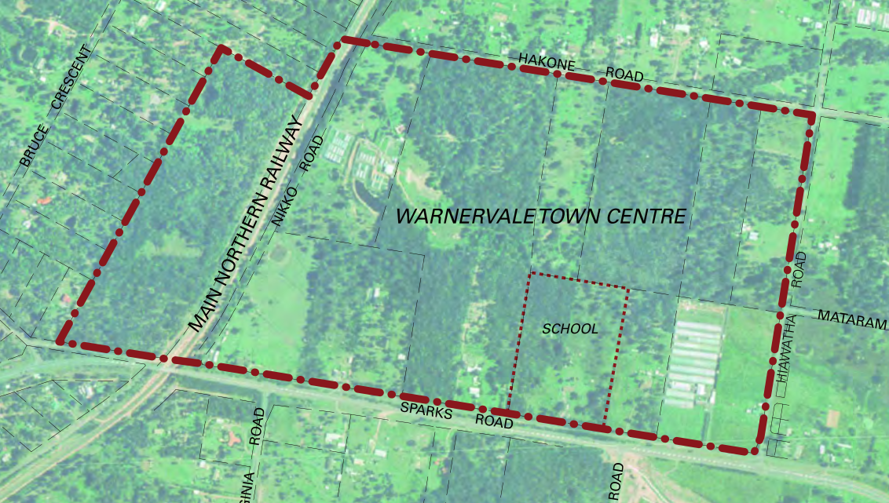
Figure 17: Warnervale Town Centre boundary
Some of the key objectives of Part 5.5 include creating a vibrant, pleasant safe town centre with housing, jobs, services, community facilities and entertainment and encouraging the use of walking, cycling and buses. The WTC is made up of various precincts of which the subject site is located within 3 Southern residential.
The population target for the WTC is 4,200 people and 1,646 dwellings. A mix of housing types and forms are to be provided across the WTC. The WTC is also to provide for retail, business and bulky goods uses and employment objectives. The site is predominantly zoned R1 General Residential with a small part B4 Mixed Use. The proposed subdivision will allow for the development of residential dwellings to meet the dwelling target.
The proposal consists of the subdivision of the parcel of land and the associated roads. The relevant sections of the Chapter that apply to the proposal have been addressed in Attachment B to this report.
A variation is proposed in relation to the road layout hierarchy and design construction widths.
Road Layout and Hierarchy
The proposal seeks a non- numerical variation to Clause 3.2 of the DCP which relates to the road layout, road hierarchy and street types. The internal roads proposed, which are identified as being Type 11, are all proposed to be varied from the DCP standards. The north south Type 11a road is deleted along the eastern boundary of the site.
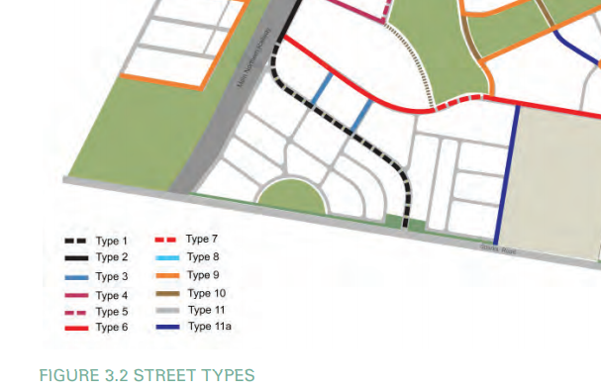
Figure 18: WDCP Road Layout and Street Types
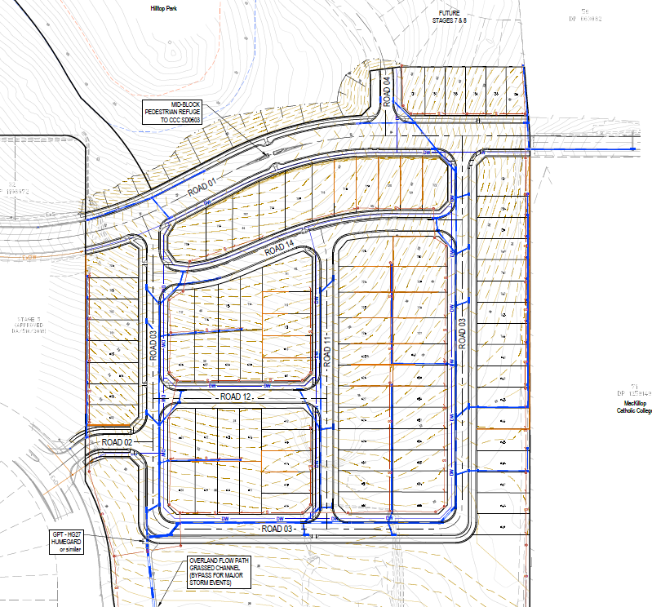
Figure 19: Proposed Road Pattern
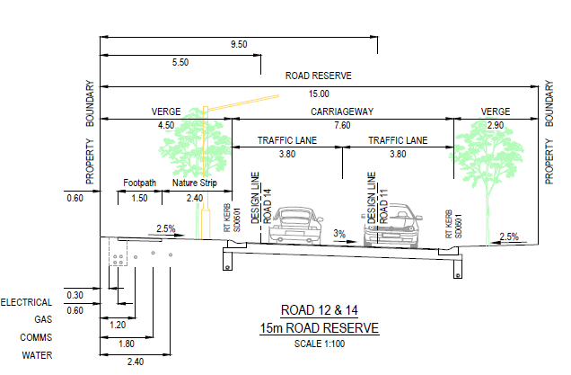
Figure 20: Proposed Typical Road Section roads 12 & 14
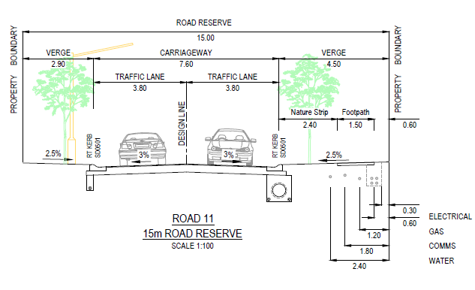
Figure 21: Proposed Typical Road Section road 11

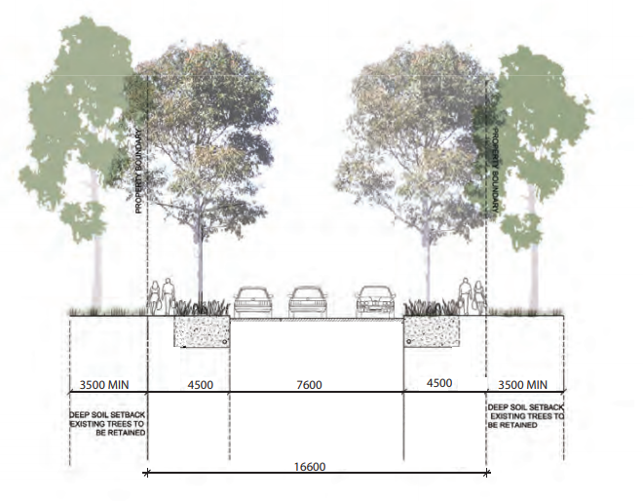
Figure 22: DCP Typical Road Section – Type 11
The proposed variations allow for orderly development and the provision of suitable lots. The provision of a full 16.6m wide road reserve is not considered necessary to accommodate the paved road, footpath and services and it is considered that a better outcome in terms of character can be achieved by further reinforcing the road hierarchy through reduced road reserves in the central part of the development. Existing approvals in the locality have allowed road reserves at 11m however, as previously discussed, this would not allow for parking within the street and to address this and to provide for landscaping, the 15m as proposed is reasonable.
DCP Road 11a is not proposed and has been replaced with a type 11 road located one row of allotments in from the boundary for efficiency. The proposed road 03 is orderly development in that it is a more efficient provision of public road servicing lots on both sides of the road instead of one. The engineering details submitted with the s.8.2 application show that the interface between the proposed residential lots and the school will involve a change in level of less than 500mm with the maximum height of retaining being 1.2m in the northern part of the development near Mataram Road, being the steeper portion of the site. It is considered that a 2.1m boundary fence recommended in the draft conditions of consent will address privacy and amenity for the school and the future residents.
The approved plan of the school (below) indicates that road 11a is not required to provide access to the school and the replacement of road 11a by proposed road 03 is supported.
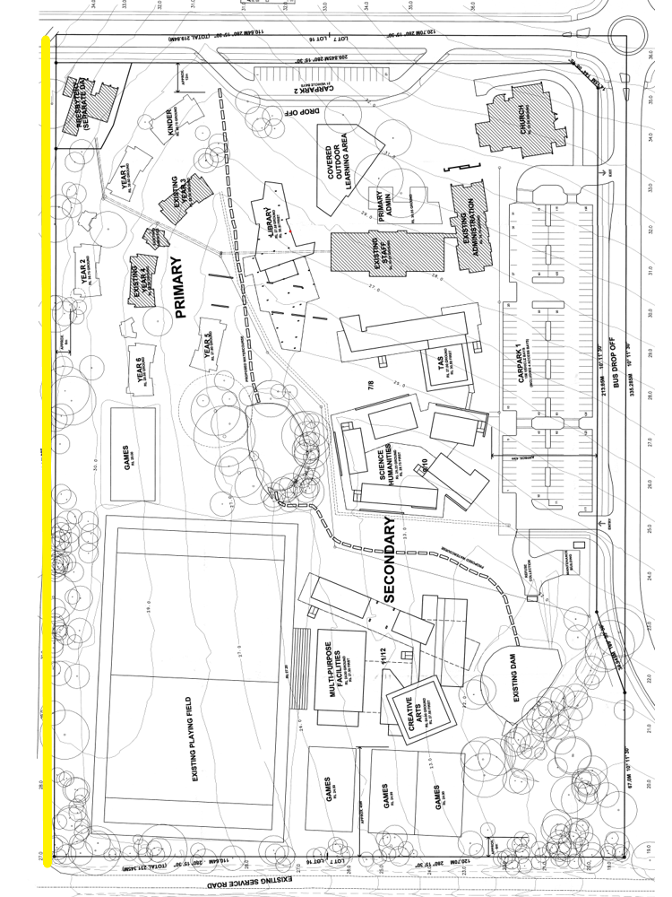
Figure 23: Approved layout of adjoining school (boundary to subject site in yellow)
The following contributions plans are relevant pursuant to Section 7.18 of the EP&A Act and have been considered in the recommended conditions (notwithstanding Contributions plans are not DCPs they are required to be considered):

- Warnervale District S7.11 Development Contributions Plan 2021

The land is located within the Warnervale District Contributions Plan and the Shire Wide Infrastructure, Services and Facilities Development Contributions Plan. The applicable contribution amount has been calculated and imposed as a condition of consent requiring the contribution to be paid prior to the release of the Subdivision Certificate. The site is a greenfield site and does not receive a credit for the existing lot. The Contributions Plans have been considered and included the recommended draft consent conditions.

  - Section 4.15(1)(a)(iiia) – Planning agreements under Section 7.4 of the EP&A Act

There have been no planning agreements entered into and there are no draft planning agreements being proposed for the site.

  - Section 4.15(1)(a)(iv) - Provisions of Regulations

There are no matters related to Clause 92(1) of the Regulation which warrant elaboration upon.
  - Section 4.15(1)(b) - Likely Impacts of Development

The likely impacts of that development, including environmental impacts on both the natural and built environments, and social and economic impacts in the locality must be considered. In this regard, potential impacts related to the proposal have been considered in response to SEPPs, LEP and DCP controls outlined above and the Key Issues section below.

The consideration of impacts on the natural and built environments includes the following:

Context and setting – The proposal is considered to be generally consistent with the a) Built Environment
A thorough assessment of the aspects of the proposed development on the built environment has been undertaken in terms of DCP compliance.
Roads and Access
The road/street hierarchy for the Warnervale Town Centre DCP 2012 has been previously determined by the NSW Department of Planning Part 3A approval process. The proposed amendments to the layout and road typology are supported.

Engineering Matters
The civil design of the proposal has been the subject of detailed consideration by Council’s engineers and the amended proposal is considered acceptable.
Earthworks
Earthworks will generally consist of cut and fill to form design levels for the proposed lots and roads. A concept bulk earthworks plan has been submitted for the site. The earthworks volumes indicate a need to import fill material. Sedimentation and erosion controls wil be implemented during construction works.
The subdivision layout is consistent with the design envisaged for the WTC and while there will be some impacts during construction, these can be addressed by standard conditions of consent.
b) Natural Environment
There will be no significant impact upon the natural environment not already anticipated by the planning controls and biodiversity certification of the site. The subject site within Stages 6a, 6b and 7 will be largely cleared. Ecological Assessments prepared by Travers were submitted to Council as part of the proposed development which provided an acceptable Assessment of Significance under the Environment Protection and Biodiversity Conservation Act 1999 (EPBC Act) and demonstrated that the proposed development will not have a detrimental impact on the ecology within the site.
The effects on the vegetation and ecology on the site, and within the adjoining sites, are considered reasonable. There will be no significant impact upon the natural environment because of the proposal.
c) Access and Transport
The impact of the proposal on access, parking and the road network is considered satisfactory for the reasons previously discussed in the report.
d) Context and Setting
The site is located within the R1 General Residential zone under WLEP 2013, and the proposal is for a residential subdivision which is a permissible development within the zone. Future development of the B4 land will be the subject of a separate development consent.
The impacts of the proposal have been considered in the assessment of the application. The proposal is consistent with the desired future character of the urban release area.
e) Economic Impacts
The proposed development will represent a positive opportunity to improve the local economy by providing additional housing within the local area.

f) Social Impacts
The proposal can deliver public benefit to the community by providing additional housing for the needs of the community within a planned urban release environment. All other relevant issues regarding the likely impacts of the development have been discussed throughout this report. In general, it is considered that the property is suitable for a residential subdivision and dwellings.
Accordingly, it is considered that the proposal will not result in any significant adverse impacts in the locality as outlined above.

  - Section 4.15(1)(c) - Suitability of the site

The subject site is suitable for the development and the proposal is in accordance with the desired outcomes for the land as contained in the relevant planning instruments and strategies. The proposal has been designed to adequately address the site constraints and there are no constraints that would render the site unsuitable for the proposed development.

  - Section 4.15(1)(d) - Public Submissions

These submissions are considered in Section 3 of this report.

  - Section 4.15(1)(e) - Public interest

North Wyong Structure Plan

The site contains areas identified as ‘proposed residential areas’ (Precinct 5) under the North Wyong Structure Plan (NWSP) which is identified for development in the medium term, to a density of 15 dwellings per hectare. The proposal is generally consistent with the Structure Plan and as discussed in the report, the density proposed is reasonable in the context of the site.

Central Coast Regional Plan 2036

The site is identified by the Central Coast Regional Plan 2036 as being an urban release area within the northern growth corridor and the proposed development supports action 2.11 by contributing to the establishment of Warnervale as a centre.

Ecologically Sustainable Development
The proposal has been assessed having regard to ecologically sustainable development principles and is considered to be consistent with the principles.
The proposed development is considered to incorporate satisfactory stormwater, drainage and erosion control and the retention of vegetation where possible and is unlikely to have any significant adverse impacts on the environment and will not decrease environmental quality for future generations.
Climate Change
The potential impacts of climate change on the proposed development have been considered by Council as part of its assessment of the application.
This assessment has included consideration of such matters as potential rise in sea level; potential for more intense and/or frequent extreme weather conditions including storm events, bushfires, drought, flood and coastal erosion; as well as how the proposed development may cope / combat / withstand these potential impacts. In this particular case, the following matters are considered to warrant further discussion, as provided below:
Sustainable building design: The proposal is for a subdivision and does not trigger initiatives for energy and water efficiency.
Bushfire Protection: The site is identified as bushfire prone land and was referred to the NSW RFS for concurrence who provided conditions relating to bushfire mitigation measures to be included with any consent granted.
Reduced Car Dependence: The proposed development is part of a broader pattern of urban expansion which will be supported by cycleways and bus services.
Rising Sea Level: The site is not impacted by flooding and is not susceptible to impacts of sea level rise.

The application provides for the subdivision of land and makes provision for the orderly development of vacant residential lots to meet the housings needs of the Central Coast. The proposed development is consistent with the broader strategic planning framework and is in keeping with the public interest.

- REFERRALS AND SUBMISSIONS

  - Agency Referrals and Concurrence

The development application has been referred to various agencies for comment/concurrence/referral as required by the EP&A Act and outlined below in Table 5.

Table 5: Concurrence and Referrals to agencies
Agency | Concurrence/  referral trigger | Comments  (Issue, resolution, conditions) | Resolved
Concurrence Requirements (s4.13 of EP&A Act)
 |  |  | N/A
Referral/Consultation Agencies
Transport for NSW | Cl 104 – Infrastructure SEPP  Development that is deemed to be traffic generating development in Schedule 3. | The development is not a traffic generating development however, consultation was carried out with Transport for NSW who raised no objection to the proposal. The matters raised for consideration in the assessment of the application have been address. | Y
Integrated Development (S 4.46 of the EP&A Act)
RFS | S100B - Rural Fires Act 1997  bush fire safety of subdivision of land that could lawfully be used for residential or rural residential purposes or development of land for special fire protection purposes | The RFS have issued a Bushfire Safety Authority with respect of the Development pursuant to S100B of the Rural Fires Act 1997. | Y
Natural Resources Access Regulator | S89-91 – Water Management Act 2000  water use approval, water management work approval or activity approval under Part 3 of Chapter 3 | The Natural Resources Access Regulator has advised that a Controlled Activity Approval is not required and accordingly GTA’s have not been issued. | Y

  - Council Referrals

The development application has been referred to various Council officers for technical review as outlined Table 6.

Table 6: Consideration of Council Referrals
Officer | Comments | Resolved
Engineering | Council’s Engineering Officer reviewed the submitted road, earthworks and stormwater concept plans and has no objection to the proposed development subject to conditions. | Y
Traffic | Council’s Traffic Engineering Officer reviewed the proposal and has not raised concerns regarding the proposed road design or traffic generation. | Y
Ecology | Council’s Ecologist raised concern that the Bushfire Safety Authority requires the entire site to be maintained as an asset protection area. The site referred to by the RFS is the residential subdivision and not the residue lots. The RFS GTA’s require that lots 731-736 not be developed for a purpose other than a class 10 building until the residue and adjoining land is developed. | Y
Contributions | Contributions are payable in accordance with the relevant plans. State Infrastructure Contributions will also apply to the proposed development. | Y
Water and Sewer | No objections to the proposed development subject to conditions. | Y
Environmental Health | Having regard to the considerations under SEPP 55 conditions are recommended requiring the submission of a site audit statement and an unexpected finds management plan.  To address the requirements of SEPP infrastructure with regard to noise, and for the amenity of future residents, a condition is recommended regarding an 88B restriction on title requiring compliance with the relevant dB(A). | Y

The outstanding issues raised by Council officers are considered in the Key Issues section of this report.

  - Community Consultation

The proposal was notified in accordance with Wyong DCP 2013, Chapter 1.2-Notification of Development Proposals, from 25 June 2021 until 23 July 2021. The notification included the following:

- Notification letters sent to 26 adjoining and adjacent properties.
- Notification on the Council’s website.

The Council received no unique submissions.

- KEY ISSUES
The following key issues are relevant to the assessment of this application having considered the relevant planning controls and the proposal in detail:

  - Stormwater Drainage

Drainage discharge from the proposal (as submitted) was estimated to exceed the capacity of the existing detention basin/biofilter system in stages 1-4. A redesign was requested to discharge stormwater through the culverts under Sparks Road. To achieve this, the basin would need to be relocated to the bottom of the catchment adjacent to the culverts and increased in size to meet the detention requirement set by TfNSW and the water quality requirements set by Council.
The proposed catchment scheme is included below for reference.
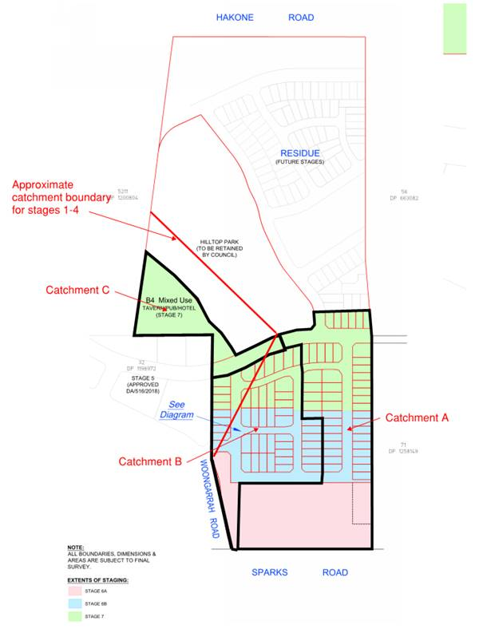
Figure 24: Proposed catchment boundaries

The catchment boundary of the basin design in stages 1-4 is shown in bold red, and the proposed new catchment boundaries for catchments A, B and C are outlined in black.
Catchment B has significantly increased in size to the original engineering report which further increases the discharge to the basin in stages 1-4 above the design criteria for the basin and biofilter design.
Catchment A has decreased in size with the proposed basin and water quality device located part the way uphill from the drainage discharge point under Sparks Road, leaving a large part of the residue lot untreated.
The drainage design is required to be amended for the catchment boundaries of catchment A and B to reflect the design catchment of the basin and biofilter in stages 1-4. This will require most of the site to discharge through the drainage system under Sparks Road. The basin will need to be appropriately sized for this catchment and relocated adjacent to the discharge point for the whole development to be accommodated.
Applicant’s Response:

‘To remedy the drainage discharge issue, the drainage design has been amended to discharge requisite amounts of stormwater into the relevant catchment.
The basin has been relocated from the upper eastern corner of the residue lot to the lower western corner in vicinity of the culverts under Sparks Road.

The proposed stormwater basin includes both the management of Stormwater Quantity and Quality and satisfies the objectives of the Central Coast Council Development Control Plan and Water Sensitive Urban Design Guidelines.

The Stormwater Drainage Quantity Management includes the attenuation of post-developed flows to match or discharge below the pre-developed flows using an On-Site Detention (OSD) basin. Quantity management is also governed by the capacity of the existing stormwater culvert under Sparks Road where the storm water basin drains.

Stormwater Drainage Quality Management includes a treatment train of devices to reduce pollutant levels generated from the post-developed site condition. Devices such as Gross Pollutant Traps (GPTs), Bio-retention basin and rainwater tanks combine to provide the treatment train and reduce the pollutant levels before discharging to the downstream stormwater drainage network. An overland flow path has been provided in the form of a grass channel. This conveys storm water flows to the basin in the unlikely event that the capacity of the piped storm water system becomes blocked or the capacity is exceeded.
An easement is proposed over the stormwater basin with a positive covenant for maintenance and upkeep, at the appropriate juncture. The reason for an easement rather than a separate lot is due to having flexibility to adjust the shape or location when the residue lot is to be developed in the future. The development of Lot 601 will be subject to a future DA. It is noted that the stormwater basin caters for stormwater drainage from the residue lot…’ (Refer Figure 25 below).

Figure 25: Revised catchment boundaries

Council Comment:
The revised Civil Engineering Report prepared by Beveridge Williams consulting addresses stormwater management for the site. The report provides details of stormwater quantity and quality management.
The proposed development has been split into three individual catchments, part of the site will drain to the west to existing development, discharging to the existing regional bio-retention basin constructed as part of stage 1-4 works, which has been sized catering for flows from the fully developed catchments. Part of the site will drain to the east, and most of the site will drain south to Sparkes road. Details are provided in the revised Stormwater report and Engineering plans prepared by Beveridge Williams.

Flows from catchment A1 (majority of the site) are to be attenuated and treated to the capacity of the twin 1050mm pipe culverts under Sparks Road in accordance with the TfNSW requirements. This includes detention being provided to the culvert system based on a 50% blockage factor to the system.
A stormwater detention and water quality basin will be constructed on lot 601 at the low point of the catchment. This basin is permanent and is proposed to be retained in the ownership of lot 601 which is the residue lot. Appropriate easements and covenants will be created over the drainage system and basin within lot 601, benefiting Council.
It is considered that the key issue of stormwater drainage has been satisfactorily resolved.

  - Road Design
To comply with the RFS GTA’s parking restrictions, No Stopping signs would have been required to be placed for the entire length and both sides of Roads 12 and 14. While the proposed design as originally submitted, accommodated the minimum engineering requirement for the conveyance of traffic and services, it was considered that having ‘No Stopping’ and provision of street trees only on one side of the road, but only in these roads, would result in a reduction of the amenity of future residents. It was considered that provision needed to be made for the accommodation of sufficient road width to allow for parking and additional landscaping within Roads 12 and 14.
Road 11 has a 7.6m wide carriageway with a narrow verge of 1.5m on one side. The narrow verge is an acceptable engineering solution but restricts pedestrian movement and planting of street trees. It was considered that an increased verge would improve the public domain without detrimentally impacting the amenity or viability of the adjacent lots.
Applicant’s Response:
Council’s comments regarding the width of the roads have been considered. The roads have been widened and are now 15m consisting of a 4.5m verge, 7.6m carriageway, 2.9m verge. The roads are shown on the amended plans as Road 12 and 14. The increased verge width provides for on street parking, adequate area for services and street trees. The increased width has removed the need for “No Stopping” signs on both sides of the street as one side can accommodate on-street parking. Adequate street landscaping can be provided, and the amenity of the occupants will not be impacted.
The width of north south road MC11 has also been widened to 15m which allows the street to be adequately landscaped resulting in a much improved and valued amenity. The widened road is shown on the amended plans as Road 11.
Council Comment:
The revised road design is considered to provide a balance between practical access to the future lots while retaining a distinct hierarchy within the neighbourhood sought to be established through the provision of more compact spaces. The additional area for landscaping within the public domain is highly desirable given the limited areas available for the planting of trees within the future lots.
It is considered that the key issue of road widths has been satisfactorily resolved.

  - Earthworks and Retaining Details
Retaining wall details were submitted for the lots fronting Mataram Road and retaining walls were shown throughout the development however, details including maximum wall height and typical sections were not provided for assessment. Retaining wall details were requested in addition to an analysis of the overshadowing associated with the retaining wall along the Mataram Road frontage of lots 705-722.
Applicant’s Response:
Additional details have been submitted which includes all retaining wall heights, cross sections, and indicative overshadowing along Mataram Road.
Cross sections now show the Mataram Road/residential lot stepped cross section and the typical retaining wall to be used on boundaries. Refer to retaining wall diagrams in Concept Engineering Drawings.
Figure 26: Typical retaining details

Shadow diagrams for the retaining wall with a 1.8m boundary fence are provided. The shadow diagram shows the shadow cast from the retaining wall along the Mataram Rd frontage affects what will be the backyards of Lots 705-710 and 718-722 mostly at 9am. The midday and 3pm shadow cast by the wall and fence are minimal. The shadow diagrams show that the lots affected will have more than adequate solar access during mid-winter. Please refer to Shadow Diagrams plan attached.

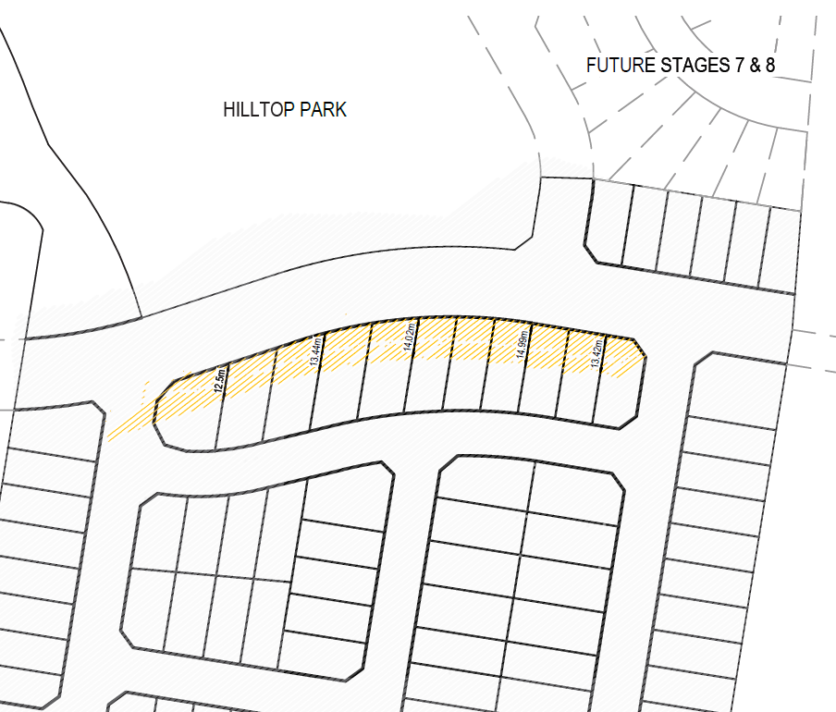
Figure 27: Overshadowing 21 June at 9:00am

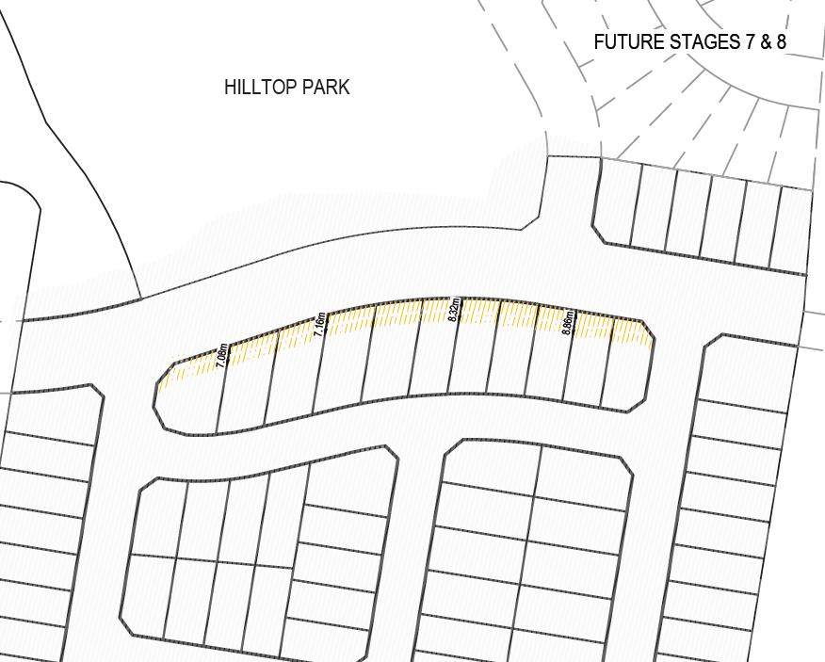
Figure 28: Overshadowing 21 June at 12:00pm

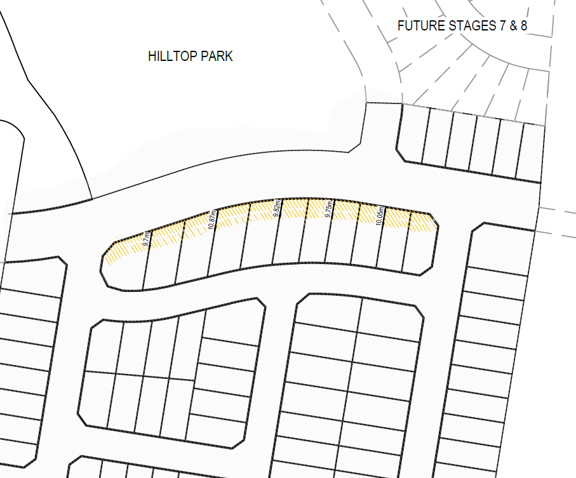
Figure 29: Overshadowing 21 June at 3:00pm

Council Comment:
The retaining wall details provided demonstrate that typical retaining wall heights proposed throughout the development are at maximum 1m or less which is reflective of the topography and development within WTC. The changes in levels particularly with the E-W oriented lots provides vertical rhythm and interest to the streetscape.
The safe design of Mataram Road results in a significant level change to the lots that adjoin the southern boundary of the road resulting in extensive retaining (up to 3 metres). This retaining is required so the road alignment of Mataram Road, which has already been constructed to the east of the subject site, can be continued through to the land to the west and the planned town centre itself. The portion of Mataram Road proposed under this subdivision is the missing part of Mataram Road.
The visual impact within the lots has been softened through the inclusion of a step and planter. The overshadowing analysis indicates that unfettered solar access to the future dwellings may be achieved.
It is considered that the key issue of earthworks and retaining details has been satisfactorily resolved.
- CONCLUSION

This Section 8.2 review application has been assessed under the heads of consideration of section 4.15 of the Environmental Planning and Assessment Act 1979 and all relevant instruments and policies.

The additional information and amendments to the plans have reasonably addressed the reasons for refusal, as detailed in Table 1 within this report. Subject to the imposition of appropriate conditions, the proposed development is not expected to have any adverse social or economic impact. It is considered that the proposed development will complement the locality and meet the desired future character of the area.

Accordingly, the application is recommended for approval pursuant to section 4.16 of the Environmental Planning and Assessment Act 1979.

It is considered that the key issues as outlined in Section 4 have been resolved satisfactorily through amendments to the proposal and/or in the recommended draft conditions at Attachment A.

- RECOMMENDATION

That Development Application 919/2018 for a staged residential subdivision at 99-107 Sparks Road and 236-260 Hakone Road Woongarrah be APPROVED pursuant to Section 4.16(1)(a) of the Environmental Planning and Assessment Act 1979 subject to the draft conditions of consent attached to this report at Attachment A.

The following attachments are provided:

- Attachment A: Draft Conditions of consent
- Attachment B: Tables of Compliance
- Attachment C: Bushfire Safety Authority
- Attachment D: Subdivision Plans
- Attachment E: Civil Work Engineering Plans

